The University of Lakki Marwat
Department of Education & Research
BS (04 Years)

Duration: 04 years
Semesters: 08
Courses: 44
Maximum Credit Hours: 136

ENTRY REQUIREMENTS (Eligibility Criteria)
FA/F.Sc. with 2nd Division and 40 score in Entry Test

ANNUAL INTAKE
There are 40 places available annually:

Course Structure
1st Year
1st Semester
S.No | Course Title | Course Codes | Credit Hours
 | Functional English-I (Compulsory) | ENG-111 | 03
 | Islamic Studies(Compulsory) | ISL-111 | 02
 | Child Development (Foundation) | EDU:B1101 | 03
 | Urdu (Content) | EDU:B1102 | 03
 | General Science (Content) | EDU:B1103 | 03
 | General Methods of Teaching (Foundation) | EDU:B1104 | 03

2nd Semester
S.No | Course Title | Course Codes | Credit Hours
 | English-II (Communication Skills) (Compulsory) | ENG-121 | 03
 | Computer Literacy (Compulsory) | EDU:B1205 | 03
 | General Mathematics (Compulsory) | EDU:B1206 | 03
 | Classroom Management (Foundation) | EDU:B1207 | 03
 | Pakistan Studies (Compulsory) | PS-121 | 02
 | Methods of Teaching Islamic Studies (Professional) | EDU:B1208 | 03

2nd Year
3rd Semester
S.No | Course Title | Course Codes | Credit Hours
 | English – III (Technical Writing & Presentation Skills) (Compulsory) | ENG-231 | 03
 | Art, Crafts and Calligraphy (Content) | EDU:B2309 | 03
 | Teaching of Urdu (Professional) | EDU:B2310 | 03
 | Teaching of General Science (Professional) | EDU:B2311 | 03
 | Instructional and Communication Technology (ICT) in Education (Professional) | EDU:B2312 | 03
 | Teaching Practice (Short Term) | EDU:B2313 | 03

4th Semester
S.No | Course Title | Course Codes | Credit Hours
 | Classroom Assessment (Foundation) | EDU:B2414 | 03
 | Teaching Literacy Skills (Professional) | EDU:B2415 | 03
 | School, community and Teacher (Foundation) | EDU:B2416 | 03
 | Teaching of Mathematics (Professional) | EDU:B2417 | 03
 | Teaching of Social Studies (Professional) | EDU:B2418 | 03
 | Teaching Practice | EDU:B2419 | 03

3rd Year
5th Semester
S.No | Course Title | Course Codes | Credit Hours
 | Teaching of English (Professional) | EDU:B3520 | 03
 | Foundations of Education (Foundation) | EDU:B3521 | 03
 | Physics – I (science group) | EDU:B3222 | 03
 | Computer Science-I ( Arts group) | EDU:B3523
 | Chemistry- I(science group) | EDU:B3524 | 03
 | English- I ( Arts group) | EDU:B3525
 | Curriculum Development (Foundation) | EDU:B3526 | 03
 | Educational Psychology (Foundation) | EDU:B3527 | 03

6th Semester
S.No | Course Title | Course Codes | Credit Hours
 | Contemporary Issues and Trends in Education (Professional) | EDU:B3628 | 03
 | Physics – II (Science group) | EDU:B3629 | 03
 | Computer Science -II ( Arts group) | EDU:B3630
 | Zoology – I (Science group) | EDU:B3631 | 03
 | Islamiyat – I ( Arts group) | EDU:B3632
 | Comparative Education (Professional) | EDU:B3633 | 03
 | Introduction to Guidance and Counselling (Professional) | EDU:B4734 | 03
 | Teaching Practice (Short Term) | EDU:B4735 | 03

4th Year
7th Semester
S.No | Course Title | Course Codes | Credit Hours
 | Chemistry – II (Science Group) | EDU:B4736 | 03
 | English – II ( Arts Group) | EDU:B4737
 | Biology – II (Science Group) | EDU:B4838 | 03
 | Islamiyat – II ( Arts Group) | EDU:B4839
 | Teaching of Physical Sciences (Science Group) | EDU:B4840 | 03
 | Teaching of Computer Science (Arts Group) | EDU:B4841
 | Teaching of Biological Sciences (Science Group) | EDU:B4842 | 03
 | Teaching of English (Arts Group) | EDU:B4843
 | Research Methods in Education (Professional) | EDU:B4844 | 03

8th Semester
S.No | Course Title | Course Codes | Credit Hours
 | School Management (Professional) | EDU:B4845 | 03
 | Teaching Practice (Long Term) | EDU:B4846 | 03
 | Test Development and Evaluation (Professional) | EDU:B4847 | 03
 | Research Project (Professional) | EDU:B500 | 06
The University of Lakki Marwat
Department of Education & Research

Course Code: ENG-111 | Functional English-I (Compulsory) | 3 Credit Hours
BS (4 years) | (1st Semester)

Objectives
- Enhance language skills and develop critical thinking.
- To learn the use of practical grammatical skills
- To improve comprehension and discussion
- To learn listening and translation skills.
- To understand translation from Urdu into English and English into Urdu
- To learn presentation skills and paragraph writing.

Unit 1: Basics of Grammar
- Parts of speech and use of articles
- Sentence structure, active and passive voice
- Practice in unified sentence
- Analysis of phrase, clause and sentence structure
- Transitive and intransitive verbs

Unit 2: Comprehension
- Understating techniques of comprehension
- Rules for answering to the questions given in a passage for comprehension
- Answers to questions on a given text

Unit 3: Discussion
General topics and every-day conversation (topics for discussion to be at the discretion of the teacher keeping in view the level of students)

Unit 4: Listening
To be improved by showing documentaries/films carefully selected by subject teachers

Unit 5: Translation Skills
- Urdu to English
- English to Urdu

Unit 6: Paragraph Writing
Topics to be chosen at the discretion of the teacher

Unit 7: Presentation Skills
- Presentation format
- Presentation techniques

Unit 8: Punctuations and Spelling
- Definition of punctuation marks
- Recognition of punctuation marks (Punctuation Symbols)

Recommended Books
- Practical English Grammar by A.J. Thomson and A.V. Martinet. Exercises 1. Third edition. Oxford University Press. 1997. ISBN 0194313492
- Practical English Grammar by A.J. Thomson and A.V. Martinet. Exercises 2. Third edition. Oxford University Press. 1997. ISBN 019431350
- Writing. Intermediate by Marie-Christine Boutin, Suzanne Brinand and Francoise Grellet. Oxford Supplementary Skills. Fourth Impression 1993. ISBN 0 19 435405 7 Pages 20-27 and 35-
- Reading. Upper Intermediate. Brain Tomlinson and Rod Ellis. Oxford Supplementary Skills. Third Impression 1992. ISBN 0 19 453402 2.

The University of Lakki Marwat
Department of Education & Research

Course Code: ISL-111 | Islamic Studies (Compulsory) | 2 Credit Hours
BS (4 years) | (1st Semester)

Objectives
This course is aimed at:
  - To provide Basic information about Islamic Studies
  - To enhance understanding of the students regarding Islamic Civilization
  - To improve Students skill to perform prayers and other worships
  - To enhance the skill of the students for understanding of issues related to faith and religious life.

Unit 1: Introduction to Quranic Studies
- Basic Concepts of Quran
- History of Quran
- Uloom-ul –Quran

Unit 2: Study of Selected Text of Holly Quran
- Verses of Surah Al-Baqra related to Faith (Verse No-284-286)
- Verses of Surah Al-Hujrat related to Adab Al-Nabi (Verse No-1-18)
- Verses of Surah Al-Mumanoon related to Characteristics of faithful (Verse No-1-11)
- Verses of Surah al-Furqan related to Social Ethics (Verse No.63-77)
- Verses of Surah Al-Inam related to Ihkam(Verse No-152-154)

Unit 3: Study of Selected Text of Holy Quran
- Verses of Surah Al-Ihzab related to Adab al-Nabi (Verse No.6,21,40,56,57,58.)
- Verses of Surah Al-Hashar (18,19,20) related to thinking, Day of Judgment
- Verses of Surah Al-Saf related to Tafakar,Tadabar (Verse No-1,14)

Unit 4: Seerat of Holy Prophet (S.A.W)
- Life of Muhammad Bin Abdullah ( Before Prophet Hood)
- Life of Holy Prophet (S.A.W) in Makkah
- Important Lessons derived from the life of Holy Prophet in Makkah

Unit 5: Seerat of Holy Prophet (S.A.W) II
- Life of Holy Prophet (S.A.W) in Madina
- Important Events of Life Holy Prophet in Madina
- Important Lessons Derived from the life of Holy Prophet in Madina

Unit 6: Introduction to Sunnah
- Basic Concepts of Hadith
- History of Hadith
- Kinds of Hadith
- Uloom –ul-Hadith
- Sunnah & Hadith
- Legal Position of Sunnah

Unit 7: Introduction to Islamic Law & Jurisprudence
- Basic Concepts of Islamic Law & Jurisprudence
- History & Importance of Islamic Law & Jurisprudence
- Sources of Islamic Law & Jurisprudence
- Nature of Differences in Islamic Law
- Islam and Sectarianism

Unit 8: Islamic Culture & Civilization
- Basic Concepts of Islamic Culture & Civilization
- Historical Development of Islamic Culture & Civilization
- Characteristics of Islamic Culture & Civilization
- Islamic Culture & Civilization and Contemporary Issues

Unit 9: Islam & Science
- Basic Concepts of Islam & Science
- Contributions of Muslims in the Development of Science
- Quranic & Science

Unit 10: Islamic Economic System
- Basic Concepts of Islamic Economic System
- Means of Distribution of wealth in Islamic Economics
- Islamic Concept of Riba
- Islamic Ways of Trade & Commerce

Unit 11: Political System of Islam
- Basic Concepts of Islamic Political System
- Islamic Concept of Sovereignty
- Basic Institutions of Government in Islam

Unit 12: Islamic History
- Period of Khlaft-E-Rashida
- Period of Ummayyads
- Period of Abbasids

Unit 13: Social System of Islam
- Basic Concepts of Social System Of Islam
- Elements of Family
- Ethical Values of Islam

Recommended Books:
Ahmad Hasan, (1993), “Principles of Islamic Jurisprudence” Islamic Research Institute: Islamabad: Pakistan, International Islamic University.
Bhatia, H. S. (1989) “Studies in Islamic Law, Religion and Society” New Delhi: Deep & Deep Publications.
Dr. Muhammad Zia-ul-Haq, (2001). “Introduction to Al Sharia Al Islamia” Islamabad, Pakistan: Allama Iqbal Open University.
Hameed ullah Muhammad, ‘Introduction to Islam Mulana Muhammad Yousaf Islahi,”
Hameed ullah Muhammad, “Emergence of Islam” , Islamabad: IRI.
Hameed ullah Muhammad, “Muslim Conduct of State” Islamabad, Pakistan: Hussain Hamid Hassan, u leaf Publication.
Mir Waliullah, (1982), “Muslim Jrisprudence and the Quranic Law of Crimes” Islamic Book Service.

The University of Lakki Marwat
Department of Education & Research

Course Code: EDU:B1101 | Child Development (Foundation) | 3 Credit Hours
BS (4 years) | (1st Semester)

Objectives
After completing this course, pre-service teachers/teachers will be able to:
- Describe major theories and big themes in how children develop
- Compare the characteristics of various developmental stages according to various theorists
- Identify individual differences of students and children with special needs
- Reflect on their conceptions about child development and its implications for teaching and learning
- The main focus of the course is on the developmental stages of the child at different age levels.

Chapter 1: Introduction
- Concept and definitions of growth and development
- Principles of growth and development

Chapter 2: Stages of Physical Development
- Pre-natal stages.
- peri-natal stages
- post-natal stages

Chapter 3: Piaget’s Stages of Intellectual Development
- concept and definition of intellectual development
- Sensory-Motor Stage
- Pre-Operational Stages
- Post-Operational Stage

Chapter 4: Social Development
- Concept and definition of psycho social development
- Erik Erikson theory of psycho social development
- Social learning theories

Chapter 5: Emotional Development
- Concept and definition of emotional development
- Types of emotions
- Factors effecting emotions
- Implications of emotional development for the teachers

Chapter 6: Individual differences
- Concept of Individual differences
- Physical differences
- Intellectual differences
- Social differences
- Emotional differences
- Achievement differences

Chapter 7: Language development
- Milestones in language development
- Receptive language
- Productive language
- Structural components of a language

Recommended Books
- Bredekamp, S. & Copple, C. (eds.) (1999). Developmentally appropriate practice in early childhood programs serving children from birth through age 8. Washington, D.C.: National Association for the Education of Young Children.
- Early Childhood Development (ECD) Pakistan Website: http://www.ecdpak.com/ Encyclopedia on Early Childhood Development: (Available in English and Urdu) http://www.child-encyclopedia.com/en-ca/home.html Howes, C. & Ritchie, S. (2002). A Matter of Trust: Connecting Teachers and Learners in the Early Childhood Classroom. New York: Teachers College Press.
- Howes, C. (2012). Culture and Child Development in Early Childhood Programs:
- Practices for Quality Education and Care. New York: Teachers College Press.
- RCC; ECD Programme. Nurture: Pakistan’s Pioneer Publication on Early Childhood Development. http://www.ecdpak.com/nurture/about_nurture.html
- Search-Institute. 40 Developmental Assets for Early Childhood, K-3, Middle Childhood, & Adolescents. http://www.search-institute.org/developmental-assets/lists Steinberg, L. (1999). Adolescence, fifth edition. McGraw-Hill.

The University of Lakki Marwat
Department of Education & Research

Course Code: EDU:B1102 | Urdu (Content) | 3 Credit Hours
BS (4 years) | (1st Semester)

Objectives
The course will provide the knowledge of:
- To appreciate Urdu as a language
- To make learner aware of how to teach Urdu in an interesting and interactive manners
- To make the content of Urdu language acquisition skills vocabulary, and grammar easily comprehendible for students
- To analyze the Urdu teaching skills through micro teaching

Unit 1: Four skills of language learning
Unit 2: Listening and speaking in Urdu
Unit 3: Reading Development in Urdu
Unit 4: Writing Development in Urdu
Unit 5: Vocabulary manipulation in Urdu
Unit 6: Explaining Grammar in Urdu
Unit 7: Prose & Poetry teaching
Unit 8: Lesson Planning
Unit 9: Assessment

Recommended Books
- Kulliyat-i-Sauda by Mirza Rafi Sauda, one of the Classical Urdu poets.
- Bagh-o-Bahar by Mir Amman: An Idiomatic classical Prose.
- Sahr-ul-Bayan by Mir Hasan
- Fasana-i-Azad by Pandit Ratan Nath Sarshar.
- Jaded Urdu Grammar by Musarrat Mirza

The University of Lakki Marwat
Department of Education & Research

Course Code: EDU:B1103 | General Science (Content) | 3 Credit Hours
BS (4 years) | (1st Semester)

Objectives:
The course will enable learners to;
      - Understand scientific concepts
      - Differentiate between scientific products and scientific processes
      - Understand the underlying principle of science education
      - Apply appropriate methods and techniques for effective learning in Science

Unit 1: Nature of Science
  - Definition of science
  - Science as a process: Scientific Method
  - Science as a product: Scientific Knowledge

Unit 2: Aims / Objectives Teaching General Sciences
- History of Science Education
- Aims / Objectives of teaching General Science at Elementary level

Unit 3: Methods of Teaching General Science
- Demonstration cum-lecture method
- Discovery method
- Project method
- Other innovative method

Unit 4: Approaches of Teaching General Science
- Teaching approach (Problem solving, Inquiry techniques, Exploration, Observation, Experiment)
- Teaching Strategies (Scope & propose of practical activities; Science laboratory; Safety measure in laboratory)

Unit 5: Teaching Aids
- Need & importance of teaching aids
- Types of teaching aids
- Principles of using teaching aids
- Using low cost teaching aids

Unit 6: Characteristics of effective Science Teaching
- Characteristics of lesson planning
- Characteristic qualities of science teacher
- Effective questioning

Unit 7: Evaluation
- Designing a test
- Administering & scoring a test
- Interpreting test results

Recommended Books:
- Lawson, Anton. E. (1995). “Science teaching and development of thinking”. California: Wadsworth publishing company
- Rehman Mehmooda (1999). “Teaching of science and mathematics”. Peshawar: Ijaz printer, Pakistan

The University of Lakki Marwat
Department of Education & Research

Course Code: EDU:B1104 | General Methods of Teaching (Foundation) | 3 Credit Hours
BS (4 years) | (1st Semester)

Objectives:
After completion of this course, the students will be able to:
- Meaning, concept, and definition of teaching.
- Understand methods and techniques of classroom management skills during teaching process.
- get knowledge about various methods of teaching and its application during the teaching process.
- to learn about managing different activities occurring at the same time
- increase understanding about direct and indirect instructions.
- to learn about Teacher-student interactions that support learning in the classroom

Unit 1: Introduction to Teaching Process
- Definition and concept of teaching
- Components of teaching process
- Factors effecting teaching process.
- Characteristics of effective teaching
- Role of teacher in teaching process
- Role of learners in teaching process

Unit 2: Sources of Complexity in Classroom
- Managing a crowded space
- Working with groups and individuals
- Managing different activities occurring at the same time
- Diversity among children
- Managing scarce resources
- Coping with unexpected events

Unit 3: Managing Complexity in Classroom
- Learn names, interests, and learning strengths fast
- Establish rules and routines
- Group students
- Organize books and other materials for easy access
- Create pairs of students to help each other

Unit 4: Method, Technique and Approach
- Meaning and definition of method,
- Methods used in teaching learning process
- Meaning and definition of technique and approach
- Difference between technique and approach
- How teacher use different techniques during teaching
- Importance of using techniques in teaching learning process

Unit 5: Teachers Centred and Learner Centred Methods
- Meaning and definition of teacher centred and learners centred methods of teaching
- Difference between teacher centered and learner centred methods of teaching
- Types teacher centred teaching methods
- Types of learner centred teaching methods

Unit 6: Direct and Indirect Instruction Methods
- Distinction between lower- and higher-order learning
- Direct instruction: a method to enable lower- order learning
- Indirect instruction: a method to enable higher- order learning
- Different roles for teachers and students
- Inquiry based, problem-solving,
- project-based learning

Unit 7: Cooperative Learning Methods
- Peer teaching practice
- Rationale for cooperative learning
- Cooperative learning procedures
- Incentive structure of cooperative learning
- Limitations of cooperative learning

Unit 8: Lecture, demonstration, and discussion
- Definition of lecture demonstration method
- Advantages and disadvantages of lecture demonstration method.
- Structure of a lecture
- Active lectures
- Structure of a demonstration
- Characteristics of good discussion

Unit 9: Teacher-student interactions that support learning in the classroom
- Constructive interactions between teacher and student
(Respect, Credibility, Fairness (justice), Trust, Interest, Enthusiasm, Adaptive teaching)
- Constructive interactions between students
- Cooperative working relationships
- Feelings are the foundation of thought
- Importance of trust and confidence

Recommended Books
M. Boekarts, Motivation to Learn (Educational Practice Series No. 10) (Geneva: International Bureau of Education, 2002
J. Brophy, Teaching. (Educational Practice Series No. 1) (Geneva: International Bureau of Education, 1999).
M. A. Dasgupta, Low-Cost, No-Cost Teaching Aids (New Delhi: National Book Trust, New Delhi).
M. J. Elias, Academic and Social-Emotional Learning. (Educational Practice Series No. 11) (Geneva: International Bureau of Education, 2003W. Harlan and J. Elstgeest, UNESCO Sourcebook for Science in the Primary School (Paris: UNESCO, 1973).
B. Rosenshine, Principles of Instruction (Educational Practice Series No. 21) (Geneva: International Bureau of Education, 2010).
UNICEF, ‘What Makes a Good Teacher? Opinions from Around the World’ (1996)
S. Vosniadou, How Children Learn. (Educational Practice Series No. 7) (Geneva: International Bureau of Education, 2001).
West Virginia Department of Education, ‘Examples of Formative Assessment’,

The University of Lakki Marwat
Department of Education & Research

Course Code: ENG-121 | English-II (Communication Skills) Compulsory | 3 Credit Hours
BS (4 years) | (2nd Semester)

Objectives
Enable the students to:
- Learn about paragraph writing.
- Develop essay writing.
- Understand CV
- Write Job application
- Enhance translation, study and academic skills
- Know presentation and communication skills

Unit 1: Paragraph Writing
- Practice in writing a good, unified and coherent paragraph

Unit 2: Essay writing
- Definition and concept of essay writing
- Techniques of essay writing
- Types of essays

Unit 3: CV and Job Application
- CV writing procedure
- Types of standard CVs
- Application writing and skills
- Types of applications

Unit 4: Translation Skills
- Urdu to English
- English to Urdu

Unit 5: Study Skills
- Skimming and Scanning
- Intensive and Extensive
- Speed Reading
- Summary and Précis Writing
- Comprehension

Unit 6: Academic Skills
- Letter/Memo Writing
- Minutes of Meetings
- Use of Library
- Internet
Unit 7: Presentation Skills
- Definition of presentation
- Presentation format
- Presentation techniques
- Signs of good presentations

Unit 8: Communication Skills
- Definition and concept of communication
- Types of communications

Recommended Books
- Practical English Grammar by A.J. Thomson and A.V. Martinet. Exercises 2. Third edition. Oxford University Press 1986.
- ISBN 0 19 431350 6.
- Writing. Intermediate by Marie-Chrisitine Boutin, Suzanne Brinand and Francoise Grellet. Oxford Supplementary Skills. Fourth Impression 1993. ISBN 019 435405 7 Pages 45-53 (note taking).
- Writing. Upper-Intermediate by Rob Nolasco. Oxford Supplementary Skills. Fourth Impression 1992. (particularly good for writing memos, introduction to presentations, descriptive and argumentative writing).ISBN 0 19 435406 5
- Reading. Advanced. Brian Tomlinson and Rod Ellis. Oxford Supplementary Skills. 3rd Impression 1991. ISBN 0 19 453403 0.
- Reading and Study Skills by John Langan
- Study Skills by Riachard Yorky.

The University of Lakki Marwat
Department of Education & Research

Course Code: EDU:B1205 | Computer Literacy (Compulsory) | 3 Credit Hours
BS (4 years) | (2nd Semester)

Objectives:
Enable the students to:
- Define computer terminology
- Identify the basic components of a computer and describe the function of each.
- Use the keyboard to interact with the computer
- Describe different applications of computers in education.
- Develop skills to use computer in educational settings.
- Communicate through computer with friends, and teachers in and outside the country.
- Use computer for research, data analysis and presentations

Unit 1: Introduction
  - Definition and Importance of Computer
  - Basic Concepts of the Computer Hardware
  - Input and Output Devices
  - Functions of Computer

Unit 2: Computer Software
- Concept of Software
- Types of Software
- Applications of Computer in Education

Unit 3: Word Processing and Document Handling
- Creating, Saving and Opening a Document
- Composing and editing Educational Documents
- Inserting and resizing tables, pictures and shapes
- Line Spacing, paragraphing and formatting text
- Page Setup and Printing document

Unit 4: Spreadsheet (Excel)
- Features of M.S. Excel
- Sum/Subtractions/Multiplication/division/Percentage/ Average/ If statement
- Sorting and Filtering Data
- Inserting Charts and Graphs

Unit 5: PowerPoint
- Composing Presentations
- Delivering Presentations

Unit 6: Internet and Information Highways
- Network, Types of Network, Server and Client
- Internet, World Wide Web, Search Engines, Internet Browser
- E-Mail Management
- Online Educational Resources
- Educational databases

Unit 7: Computer Based Instructions
- Computer Based Instructions: an introduction
- Computer Assisted Instruction
- Computer Based Assessment

Unit 8: Course Evaluation
- Assignments 20
- Mid Semester Test 25
- Final Project 15
- Final Test 40
- Total 100

Recommended Books
- Faden, P.D., and Vogel, R.M. (2003). Methods of Teaching, Boston: Mc-Graw Hills.
- Joyce, B., Weil M., and Calhoun, E. (2000). Models of Teaching, 6th ed. Boston: Allyn and Bacon.
- Norton, P. (2000). Introduction to Computers 5th ed; New York: Mc-Graw Hill Book Co.
- Norton, P. (2003). Introduction to Computers, 5th ed., New York: McGraw-Hill Book Co.
- Norton, P., & Spragu, D. (2001). Technology for Teaching, Boston: Allyn and Bacon.
- Sharma, A. (1999). Modern Educational Technology, New Delhi: Prentice-Hall.
- Sharma, S. R. (2000). Effective Classroom Teaching Modern Methods, Tools and Techniques. Jaipur: Mangal Deep Publications.
- Shelly, G. B. & Vermaat, M. E. (2008). Discovering Computer. Pakistan: Book Media

The University of Lakki Marwat
Department of Education & Research

Course Code: EDU:B1206 | General Mathematics (Compulsory) | 3 Credit Hours
BS (4 years) | (2nd Semester)

Objectives
After completion of this course the student will be able to:
- Understand the use of the essential tools of basic mathematics;
- Apply the concepts and the techniques in their respective disciplines;
- Model the effects non-isothermal problems through different domains;

Algebra – I
Unit 1: Algebra Preliminaries
- Real and complex numbers
- Introduction to sets
- Set operations
- Functions
- Types of functions

Unit 2: Matrices
- Introduction to matrices
- Types of matrices
- Inverse of matrices
- Determinants
- System of linear equations
- Cramer’s rule

Unit 3: Quadratic Equations
- Solution of quadratic equations
- Nature of roots of quadratic equations
- Equations reducible to quadratic equations

Unit 4: Sequence and Series
- Arithmetic
- Geometric
- Harmonic progressions

Unit 5: Permutation and Combinations
- Introduction to permutation and combinations

Unit 6: Binomial Theorem
- Introduction to binomial theorem

Unit 7: Trigonometry
- Fundamentals of trigonometry
- Trigonometric identities

Unit 8: Graphs
- Graph of straight line
- Circle functions
- Trigonometric functions

Statistics – II
Unit 10: Statistics
- Introduction
- Meaning and definition of statistics
- Relationship of statistics with social science
- Characteristics of statistics
- Limitations of statistics
- main division of statistics

Unit 11: Frequency Distribution
- Organization of data
- array,
- ungrouped and grouped data,
- types of frequency series
- individual, discrete and continuous series
- tally sheet method
- graphic presentation of the frequency distribution
- bar frequency diagram histogram
- frequency polygon
- cumulative frequency curve

Unit 12: Measures of Central Tendency
- Mean Medium and Modes
- Quartiles,
- Deciles
- Percentiles.

Unit 13: Measures of Dispersion
- Range
- Inter quartile deviation mean deviation
- Standard deviation
- Variance
- Moments
- Skewness
- Kurtosis.

Recommended Books
- Kaufmann. J. E., ‘College Algebra and Trigonometry’, PWS-Kent Company, Boston, Latest Edition.
- Swokowski. E. W., ‘Fundamentals of Algebra and Trigonometry’, Latest Edition.
- Walpole, R. E., ‘Introduction of Statistics’, Prentice Hall, Latest Edition.
- Wilcox, R. R., ‘Statistics for The Social Sciences’,

The University of Lakki Marwat
Department of Education & Research

Course Code: EDU:B1207 | Classroom Management (Foundation) | 3 Credit Hours
BS (4 years) | (2nd Semester)

Objectives
On completion of this course trainee teachers will be able to:
- Explain the meaning and concept of classroom management
- Demonstrate the establishment of a constructive classroom learning environment
- Apply various management techniques to assist learners to be responsible for their classroom behavior
- Demonstrate classroom organization to increase student motivation
- Analyze classroom situations to minimize behavioral problems
- Organize learning within a classroom environment to maximize available resources and space according to a variety of ages and grade levels of learners and
- Evaluate classroom organization in simulated and actual classroom situations.

Unit 1: Introduction to Classroom Management
- Elements of “classroom management” in the context of elementary education
- Variety of roles of the teacher in managing the elementary classroom

Unit 2: Classroom Organization to Encourage Learner Interest and Class Participation
- The elements of classroom organization
- Impact/outcomes of various kinds of classroom organization on student behavior
- Classroom activity for managing learning
- Organizing and managing field trips and class visits

Unit 3: Design of the Effective Learning Classroom
- Identifying resources for learning
- Using displays and visuals for enhancing the learning environment in the classroom
- Seating arrangements for learning experiences
- Physical facilities to enhance the learning environment
- Evaluating the effective learning classroom
- Managing the overcrowded classroom

Unit 4: Maintaining Classroom Records
- Record-keeping systems: their establishment and maintenance

Unit 5: Incentives and Rewards in the Classroom Environment
- How to maximize student success and minimize behavioral problems in the classroom
- Incentive systems in the classroom setting

Unit 6: Managing Classroom Discipline
- Creating a positive classroom environment for student responsibility
- Strategies for managing potential disciplinary issues before they become problems

Unit 7: Assessment Criteria
- Student teachers are able to describe the elements of a positive classroom environment and explain why they have made the arrangements they have done (written assignment)
- Practical classroom construction of a positive learning environment
- Demonstrate positive classroom management through role plays and simulations
- Final examination

Recommended Books
- http://712educators.about.com/od/discipline/tp/disciplinetips.htm
- Top Ten Tips for Classroom Discipline and Management
- http://www.adprima.com/managing.htm
- Effective Praise Guidelines

The University of Lakki Marwat
Department of Education & Research

Course Code: PS-121 | Pakistan Studies (Compulsory) | 2 Credit Hours
BS (4 years) | (2nd Semester)

Objectives
- Develop vision of historical perspective, government, politics, contemporary Pakistan, ideological background of Pakistan.
- Study the process of governance, national development, issues arising in the modern age and posing challenges to Pakistan.

Unit 1: Historical Perspective
- Ideological rationale with reference to Sir Syed Ahmed Khan
- Ideological rationale with reference to Allama Muhammad Iqbal
- Ideological rationale with reference to Quaid-i-Azam Muhammad Ali Jinnah

Unit 2: Factors Leading to Muslim Separatism
- People and Land (Indus Civilization, Muslim advent & Location and geo-physical features)

Unit 3: Government and Politics in Pakistan
- Political and constitutional phases 1947-58
- Political and constitutional phases 1958-71
- Political and constitutional phases 1971-77
- Political and constitutional phases 1977-88
- Political and constitutional phases 1988-99
- Political and constitutional phases 1999 and onward

Unit 4: Contemporary Pakistan
- Economic institutions and issues
- Society and social structure
- Ethnicity
- Foreign policy of Pakistan and challenges
- Futuristic outlook of Pakistan

Recommended Books
- Afzal, M. Rafique. (1988), Political Parties in Pakistan, Vol. I, II & III. Islamabad: National Institute of Historical and cultural Research.
- Akbar, S. Zaidi. (2000) Issue in Pakistan’s Economy. Karachi: Oxford University Press.
- Aziz, K.K. Party, (1976), Politics in Pakistan, Islamabad: National Commission on Historical and Cultural Research
- Burki, Shahid Javed. (1980). State & Society in Pakistan, The Macmillan Press Ltd.
- Haq, Noor ul. (1993) Making of Pakistan: The Military Perspective. Islamabad: National Commission on Historical and Cultural Research.
- Muhammad Waseem, (1987) Pakistan Under Martial Law, Lahore: Vanguard.
- S.M. Burke and Lawrence Ziring. (1993) Pakistan’s Foreign policy: An Historical analysis. Karachi: Oxford University Press.
- Sayeed, Khalid Bin. (1967) The Political System of Pakistan. Boston: Houghton Mifflin.
- Zahid, Ansar. (1980), History & Culture of Sindh. Karachi: Royal Book Company.

The University of Lakki Marwat
Department of Education & Research

Course Code: EDU:B1208 | Methods of Teaching Islamic Studies (Professional) | 3 Credit Hours
BS (4 years) | (2nd Semester)

Objectives
- After completion of this course students will be able to:
- Explain the basic concepts of teaching.
- Demonstrate the essential attributes of the effective teacher.
- Describe the importance and types of teacher planning...
- Practice different teaching methods in classroom.
- Organize classroom discussion and demonstrate its appropriate use.
- Apply various techniques to motivate students.
- Select appropriate audio visual aids in classroom teaching.
- Prepare lesson plans.

Unit 1: Introduction
  - Definitions of Teaching
  - The concept of Effective Teaching
  - Role of teacher for conducive learning environment
  - Personal Characteristics of an Effective Teacher
  - Professional Characteristics of an Effective Teacher
  - The concepts of Teaching Methods, Strategies and Techniques

Unit 2: Lesson Planning in Teaching
- The Need for lesson Planning
- Approaches to lesson Planning
- Weekly Planning
- Daily Planning
- Unit Planning
- Course Planning

Unit 3: Steps in Lesson Planning
- Introduction
- Presentation
- Generalization
- Application
- Recapitulation
- The Lesson Plan Format

Unit 4: Pedagogy by Level
- Pedagogy of early childhood education
- Pedagogy of elementary education

Unit 5: Inquiry Method
- The Inductive Method
- Deductive Method of inquiry
- Scientific Method
- The Problem Solving Approach
- Advantages and Limitations of Inquiry Method

Unit 6: Activity Methods & Cooperative learning
- Individual Project
- Group Project
- Research Projects
- Cooperative learning
- Techniques of cooperative learning
- Advantages and Limitations of activity and cooperative Method

Unit 7: Demonstration Method
- What is Classroom Discussion?
- Planning the Discussion
- Organizing the Discussion
- Practicing in asking questions
- Practicing in answering the questions
- Assessing the discussion
- Advantages and Limitations of Discussion Method

Unit 8: Student Motivation
- Concept of Motivation
- Intrinsic Motivation
- Extrinsic Motivation
- Theories of Motivations
- Strategies to Motivate Students

Unit 9: Teaching Skills
- Set induction
- Presentation
- Identify learning difficulties of students
- Prepare lesson according to individual needs
- Students Evaluation

Unit 10: Teaching Tools
- Selecting the Audio Visual Material
- Planning To Use the Materials
- Preparing For the Audio Visual Activity
- Kinds of AV Materials (White Board / Marker, Charts, Posters, Maps, Graphs & Models, Text Books, Hand Outs, Projectors and Multimedia)

Recommended Books
- Allen, Mendler, (2009).”Motivating Students Who Don't Care”: Successful Techniques for Educators. Amazon.com
- Arends, R.I. (2007) “Learning to Teach” (7th Edition, McGraw Hill International Edition). Boston: McGraw Hill.
- Ellington, H et al. (2005) “Handbook of Educational Technology” (3rd Edition). London: Kogan Page Limited.
The University of Lakki Marwat
Department of Education & Research

Course Code: ENG-231 | English-III: Technical Writing and Presentation Skills | 3 Credit Hours
BS (4 years) | (3rd Semester)

Objectives
Enable the students to:
- Enhance language skills
- Develop critical thinking
- Learn essay writing
- Learn academic writing
- Understand technical report writing.
The Enhance language skills and develop critical thinking

Unit 1: Presentation Skills
- Definition of presentation
- Techniques of presentation
- Procedure of presentation

Unit 2: Essay Writing
- Descriptive essay
- Narrative essay
- Discursive essay
- Argumentative essay

Unit 3: Academic Writing
- How to write a proposal for research paper/term paper
- How to write a research paper/term paper (emphasis on style, content, language, form, clarity, consistency)

Unit 4: Technical Report Writing
- Concept of report
- Definition of technical report
- Progress of technical report

Recommended books
Essay Writing and Academic Writing by Schwedan, M. 2000.
Writing. Advanced by Ron White. Oxford Supplementary Skills. Third Impression 1992. ISBN 0 19 435407 3 (particularly suitable for discursive, descriptive, argumentative and report writing).
College Writing Skills by John Langan. Mc=Graw-Hill Higher Education. 2004.
Patterns of College Writing (4th edition) by Laurie G. Kirszner and Stephen R. Mandell. St. Martin’s Press.
The Mercury Reader. A Custom Publication. Compiled by norther Illinois University. General Editiors: Janice Neulib; Kathleen Shine Cain; Stephen Ruffus and Maurice Scharton. (Note: A reader which will give students exposure to the best of twentieth century literature, without taxing the taste of engineering students).

The University of Lakki Marwat
Department of Education & Research

Course Code: EDU:B2309 | Art, Crafts and Calligraphy (Content) | 3 Credit Hours
BS (4 years) | (3rd Semester)

Objectives
By the end of the semester participants will be able to:
- Explain the importance of art education and its role in child development especially for nurturing creativity, enhancing aesthetic sense and stretching imagination.
- Use tools and materials in art more skillfully
- Use of an art journal on their own artistic ideas and thoughts for refining their teaching as an art teacher
- Recognize and appreciate artists, art styles, and artwork
- Reflect and participate in art critiques as a critic and as an artist
- Initiate independent projects that allow personal interpretation and self-expression
- Identify links between art and other school subjects

Unit 1: Introduction to Arts, Crafts & Calligraphy
  - What are Arts, Crafts and Calligraphy?
  - The role of the teacher in teaching art
  - Influence of the arts in children’s development
  - Calligraphy- The emergence of Islamic calligraphy
  - Ceramics and Sculpture
  - Puppetry in Pakistan

Unit 2: History and Culture
  - Indus Civilizations
  - Exploration of history through a museum visit Art and Architecture (From Indus to Mughal)
  - Islamic Art and Calligraphy (Introduction of art and craft and calligraphy /origin from Persian artist and their calligraphy)
  - Pakistani Calligraphers ( Hanif Ramy, Sadqain, Shakir Ali, Gul gee,)
  - Review of this unit

Unit 3: History and Culture
  - Introduction to the Cubism Understand the Cubism.
  - Pakistani Artist‘s ( worked in Realism e.g. Shakir Ali Mansoor Rahi)
  - Intro about Realism
  - Pakistani Artist‘s work in Realism
  - (Ali Imam, M. Husain, Khalid Iqbal, Ana Molka) Hands-on activities
  - Abstraction
  - Origin and History of Abstract art
  - Explore the work of Pakistani artists in abstract (Ahmed Pervaiz, Lubna Latif, Maqsood Ali, Anwar Maqssod Hameed Ali)
  - Hands-on activities
  - Indigenous art
  - Pottery, ceramics, textile etc. Hands-on activities
  - Art Across the curriculum
  - Ideas to integrate art with languages, science, social studies, mathematics etc. Teachers will be facilitated to learn how illustrations, drawings and craft work can be used to understand and express the concepts of science, maths, social studies and skills in languages
  - Hands on activities and conclusion

Unit 4: Elements of Art & Principle of Design
  - Understanding elements of art (line, Shapes, color, texture, and space and volume)
  - The importance of lines and its use in art work
  - Kinds of lines
  - Use of color (Color wheels, tints, tones and shade)
  - Use of Space and value in 2D and 3D art Texture
  - (Natural and man- made)
  - Introduction of Principle of Design (unity, variety, balance, contrast, emphasis, and pattern and proportion)
  - Still life
  - Painting
  - Printing
  - Pattern making
  - Shapes- organic and geometrical shapes
  - Sculpture Landscape
  - Stick Drawing and conclusion and review of the unit

Unit 5: Assessment and Evaluation in Art, Crafts and Calligraphy
  - What is assessment in art curriculum?
  - How and why we assess creativity?
  - Review the recommendations proposed in the national curriculum grades
  - Design rubric/checklist for portfolio
  - Set criteria for presentation/display/ peer and self-assessment etc.

Recommended Books
Barnes, R. (1996). Teaching Art to Young Children 4-9. london and New York : Routledge, (1996). Eisner, E. (2002). The Arts and the Creation of Mind, Chapter 4, What the Arts Teach and How It Shows. s.l.: Yale University Press, NAEA Publications, (2002).
J., Lancaster. (1990. Art in the Primary Schoo. Bungay, Suffolk : Richard Clay Ltd, (1990. Jenkins, P.D. 1986. Art for the fun of it. A guide for teaching young children. USA : Simon & Schuster, 1986.
K., Gentle. 1993. Teaching Painting in the Primary School. UK: Redwood Books, Trowbridge, 1993.
M., Dowling. (1992). Education 3-5. UK : Athenaem, (1992).
Matthews, J. 1994. Helping Children to Draw & Paint in early Children. Children and visual representation. London : Hodder & Stoughton., 1994.
P., Gura. (1996. Resources for early Learning Children, Adults and Stuf. London : Hodder & Stoughton, (1996.
P., Tambling. (1990. Performing Arts in the Primary School. UK : Dotesios, (1990. R., Fisher. 1992. Teaching Juniors. UK : T.J. Press, 1992.
Vandal, S.H. Art Education in Pakistan: A case study of bringing art to school children at the informal level. Pakistan : s.n.
Razzak. A (2011) Children and Art- Status of art education in Pakistan: VDM. Germany Razzak. A (2009) Fun with paper bag: Feroz Sons. Lahore

The University of Lakki Marwat
Department of Education & Research

Course Code: EDU:B2310 | Teaching of Urdu (Professional) | 3 Credit Hours
BS (4 years) | (3rd Semester)

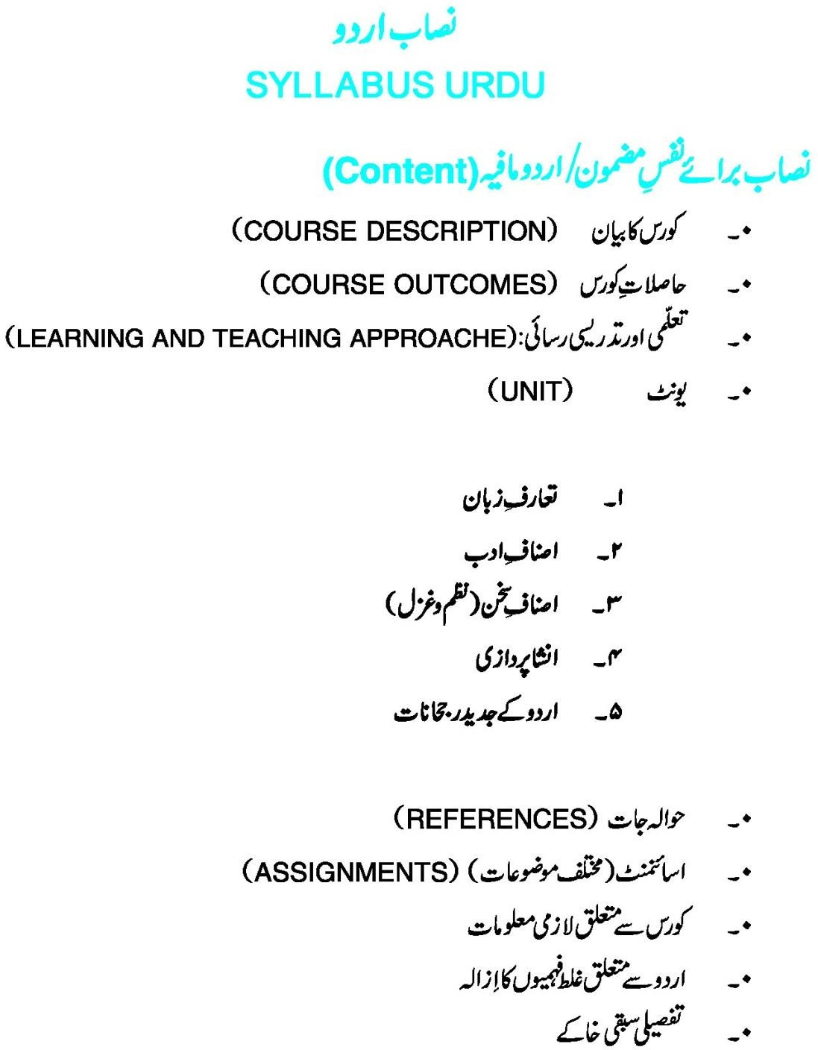
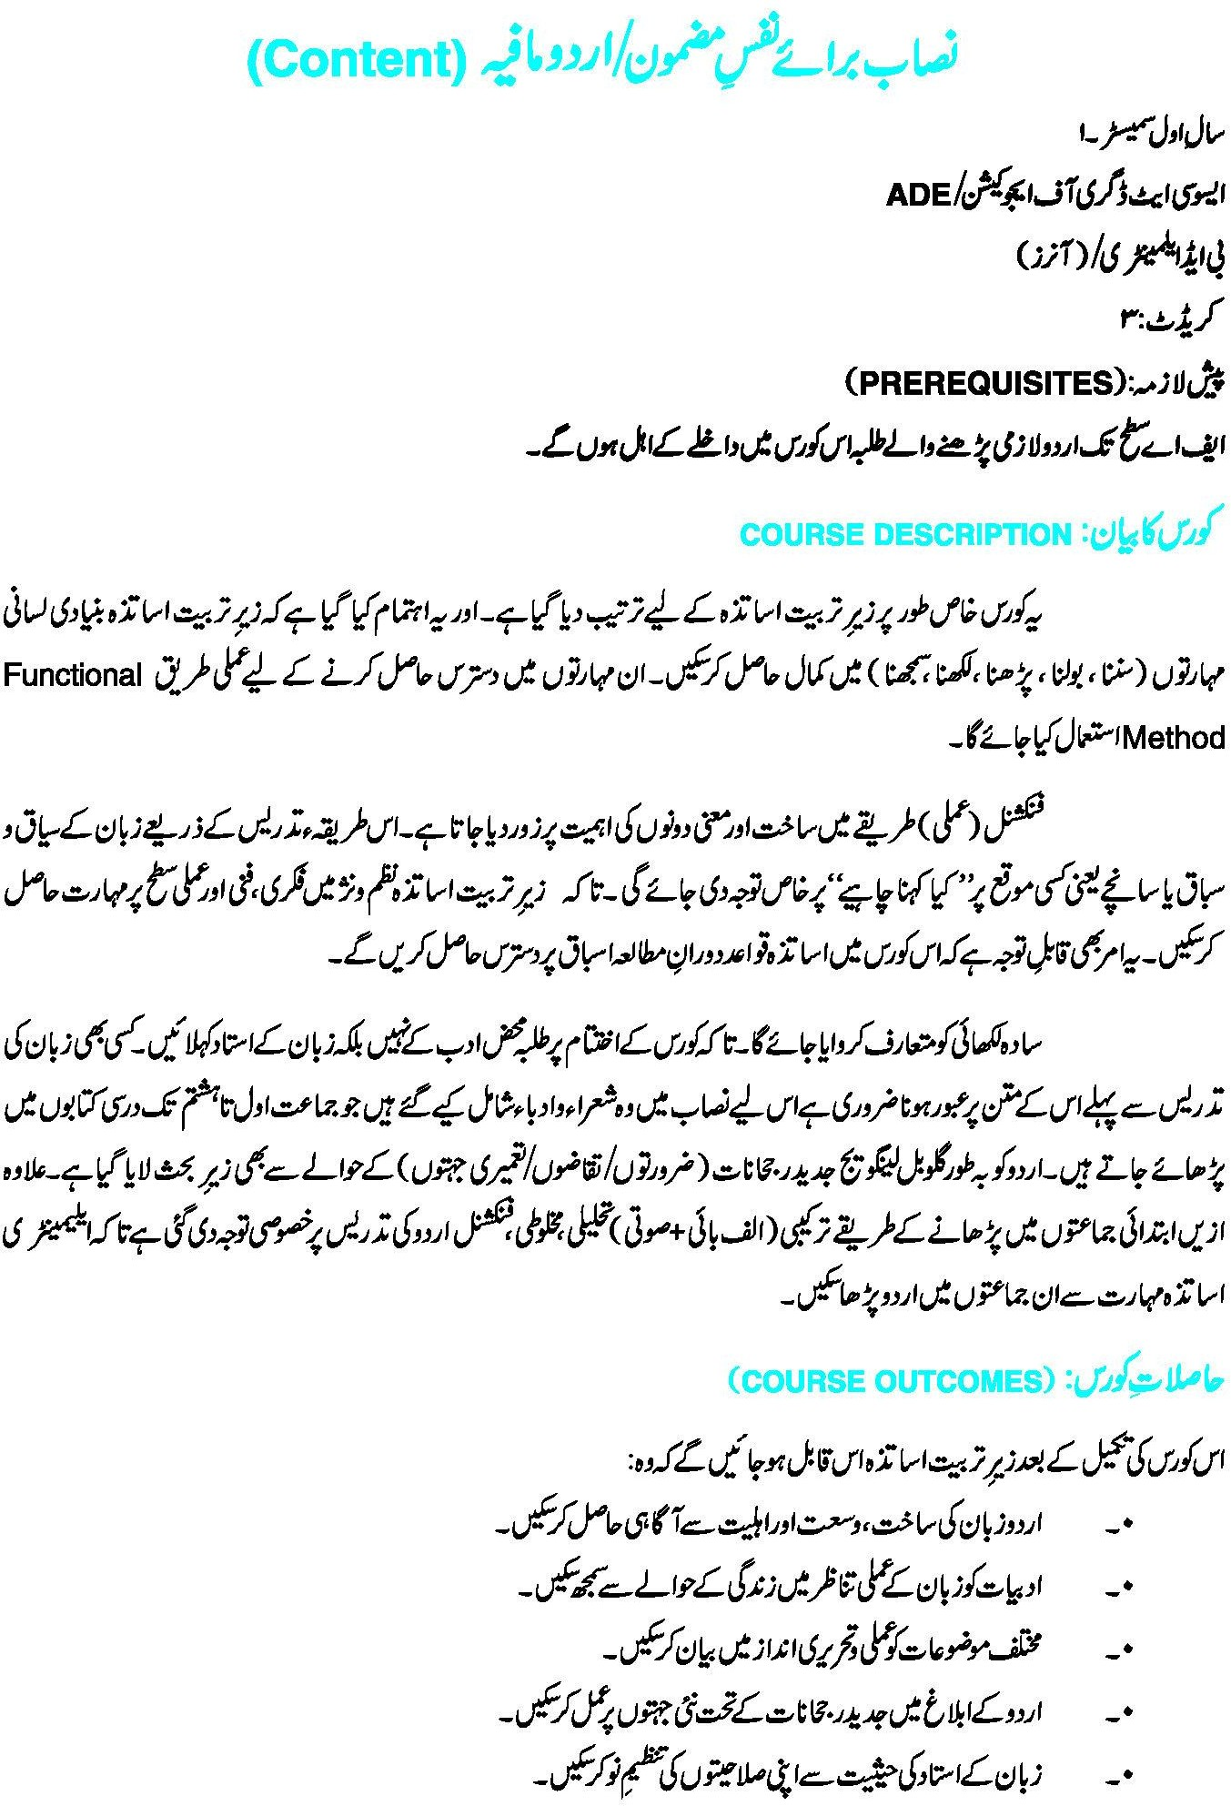

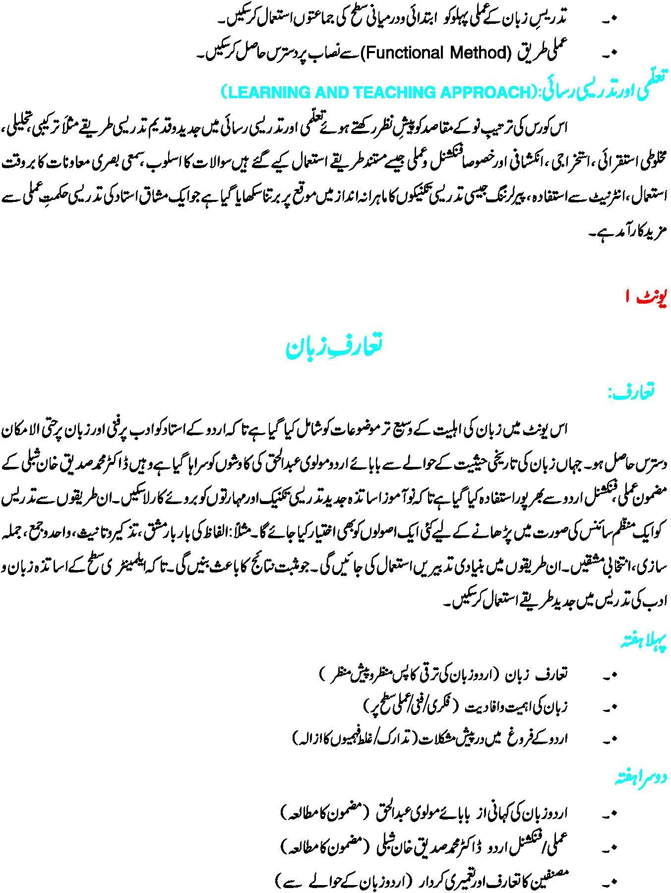

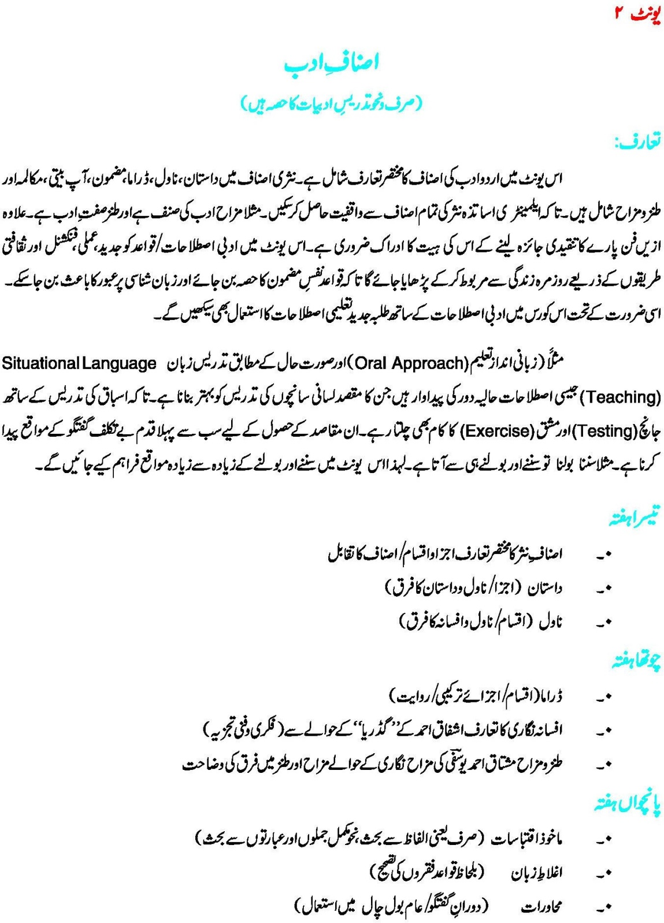

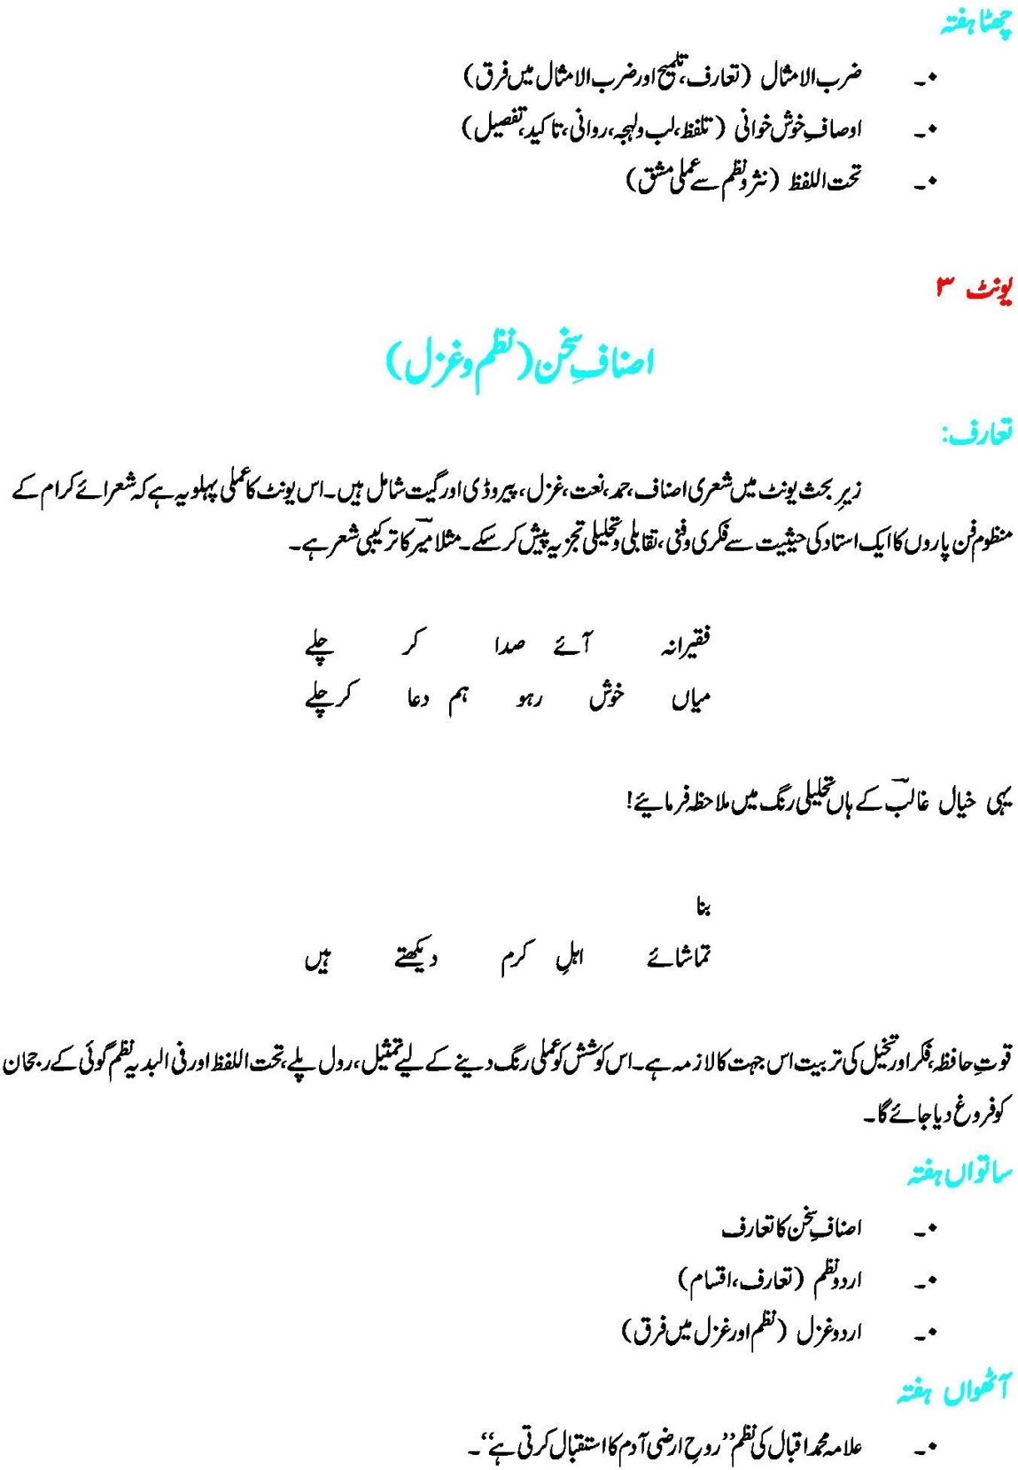

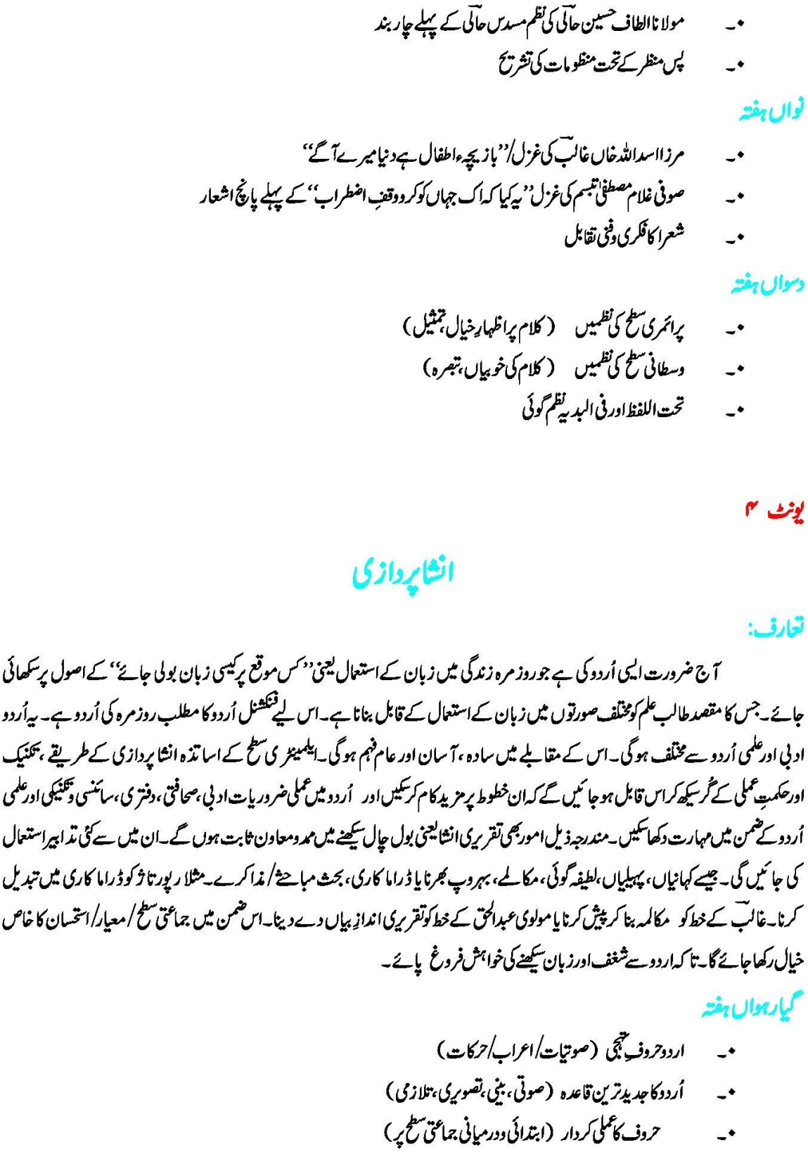

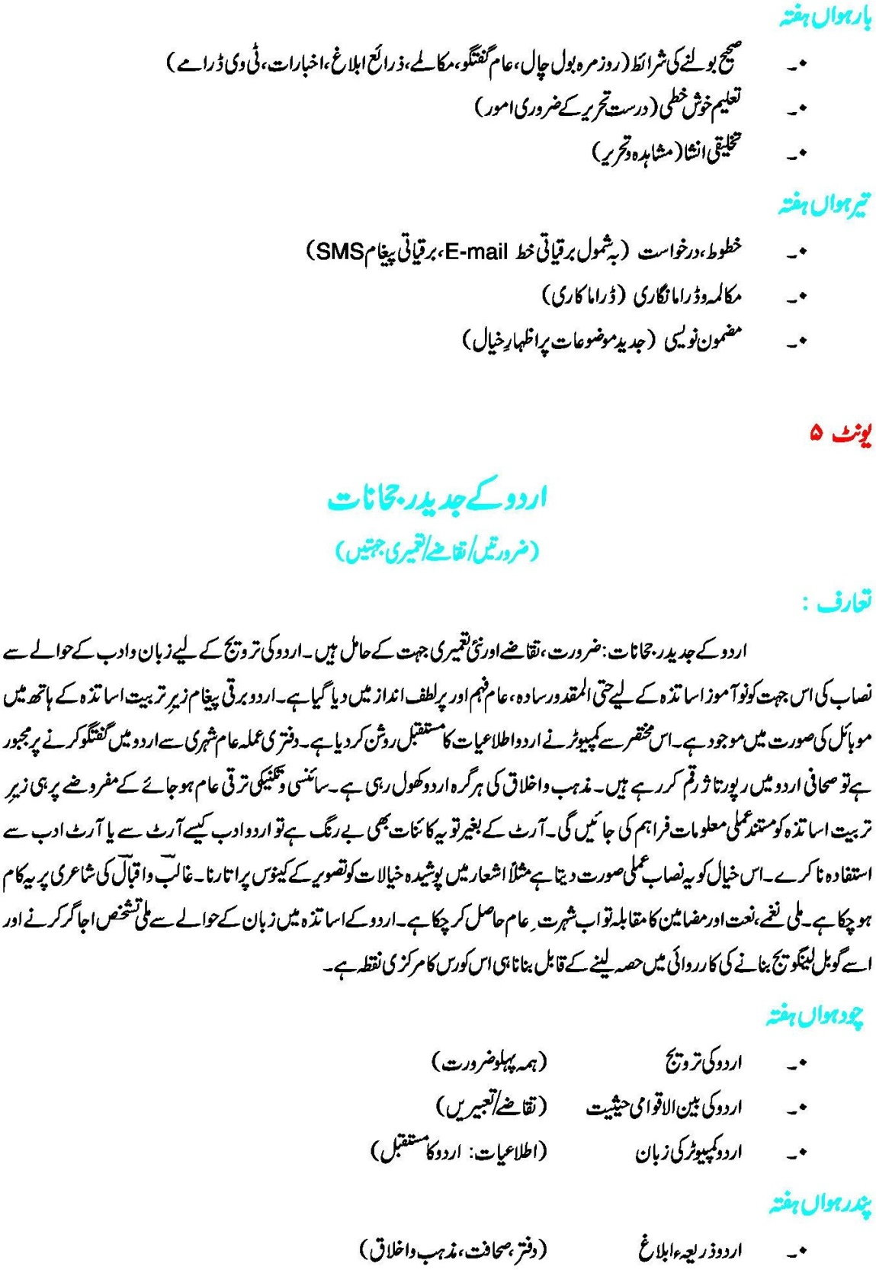

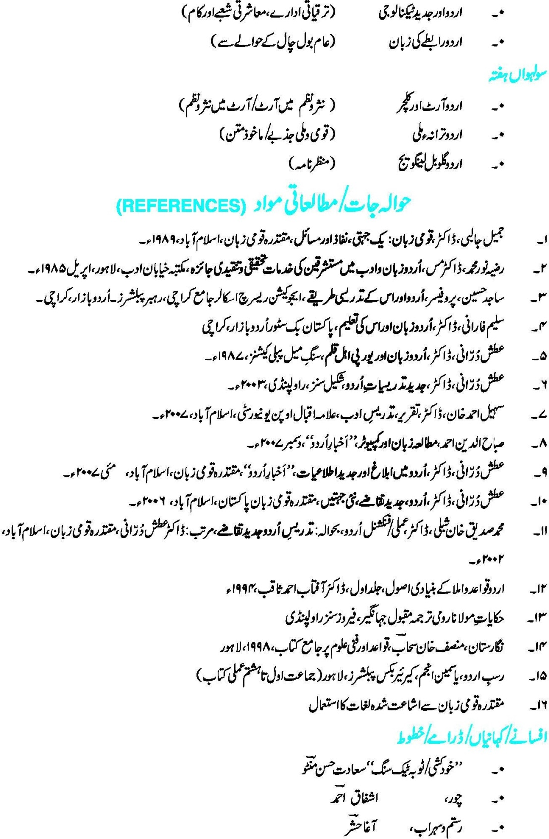

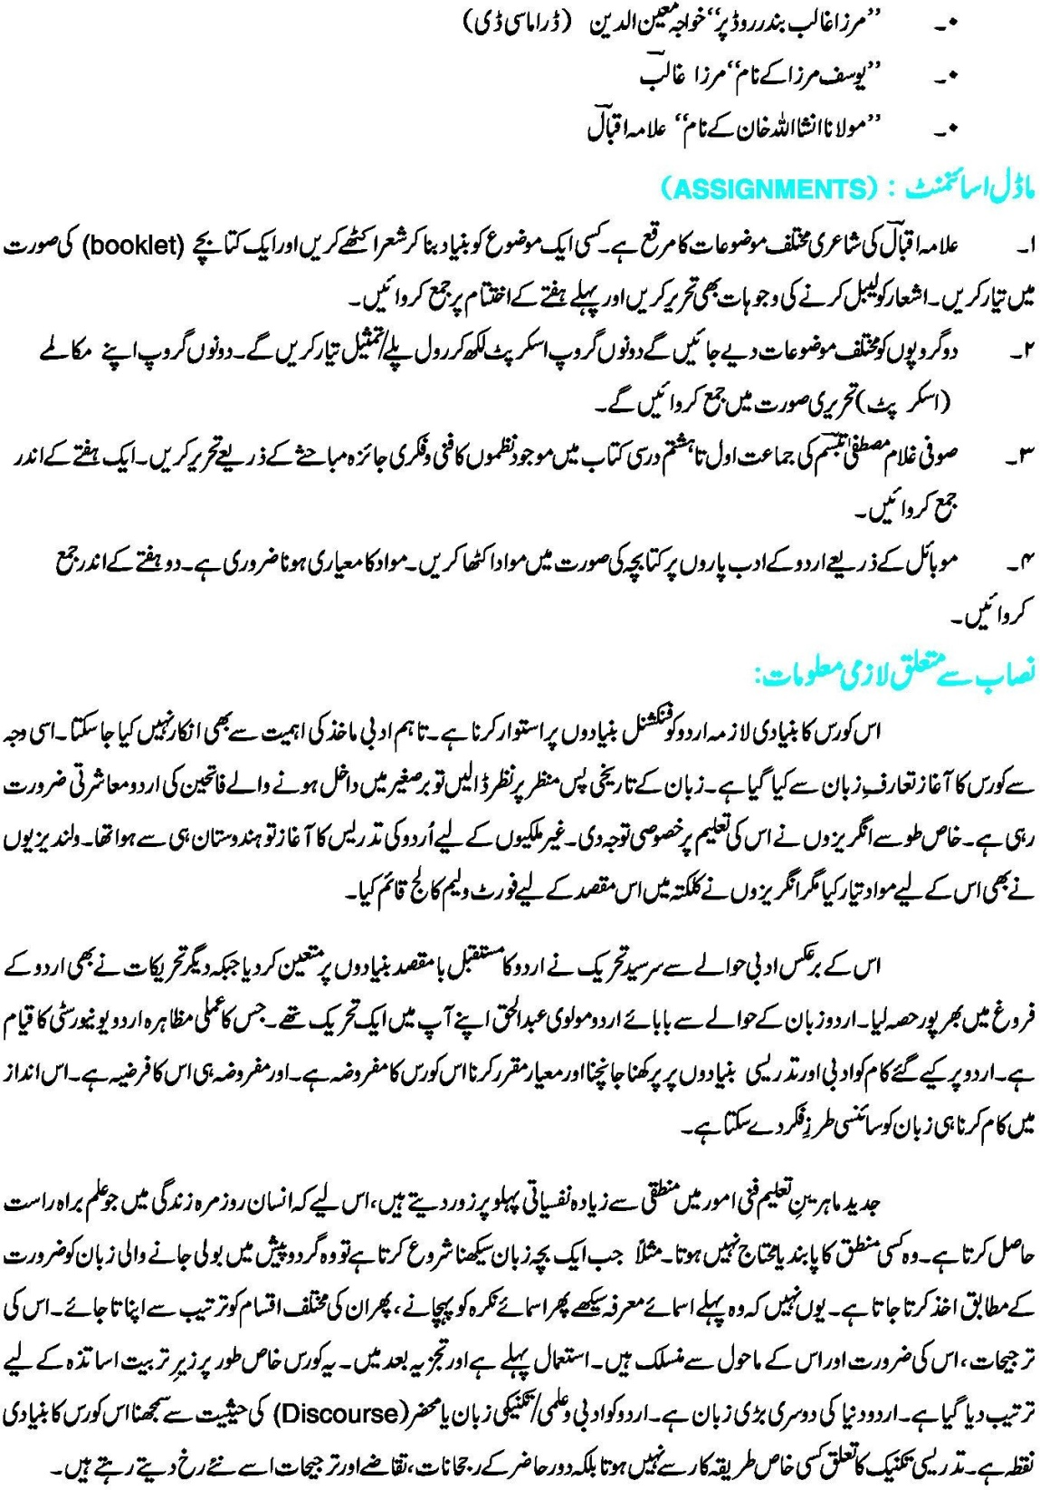

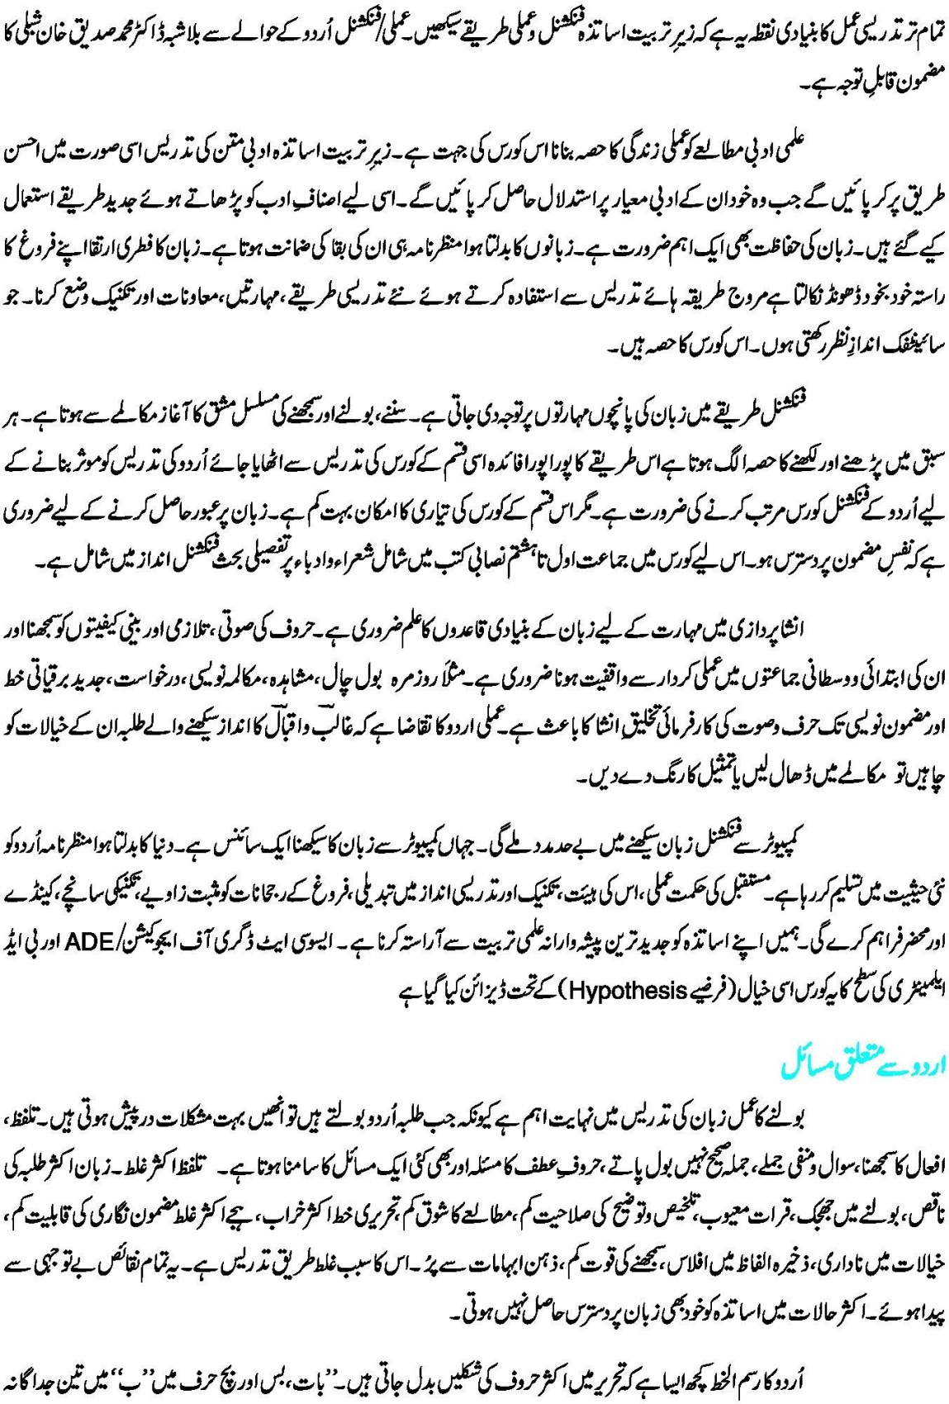

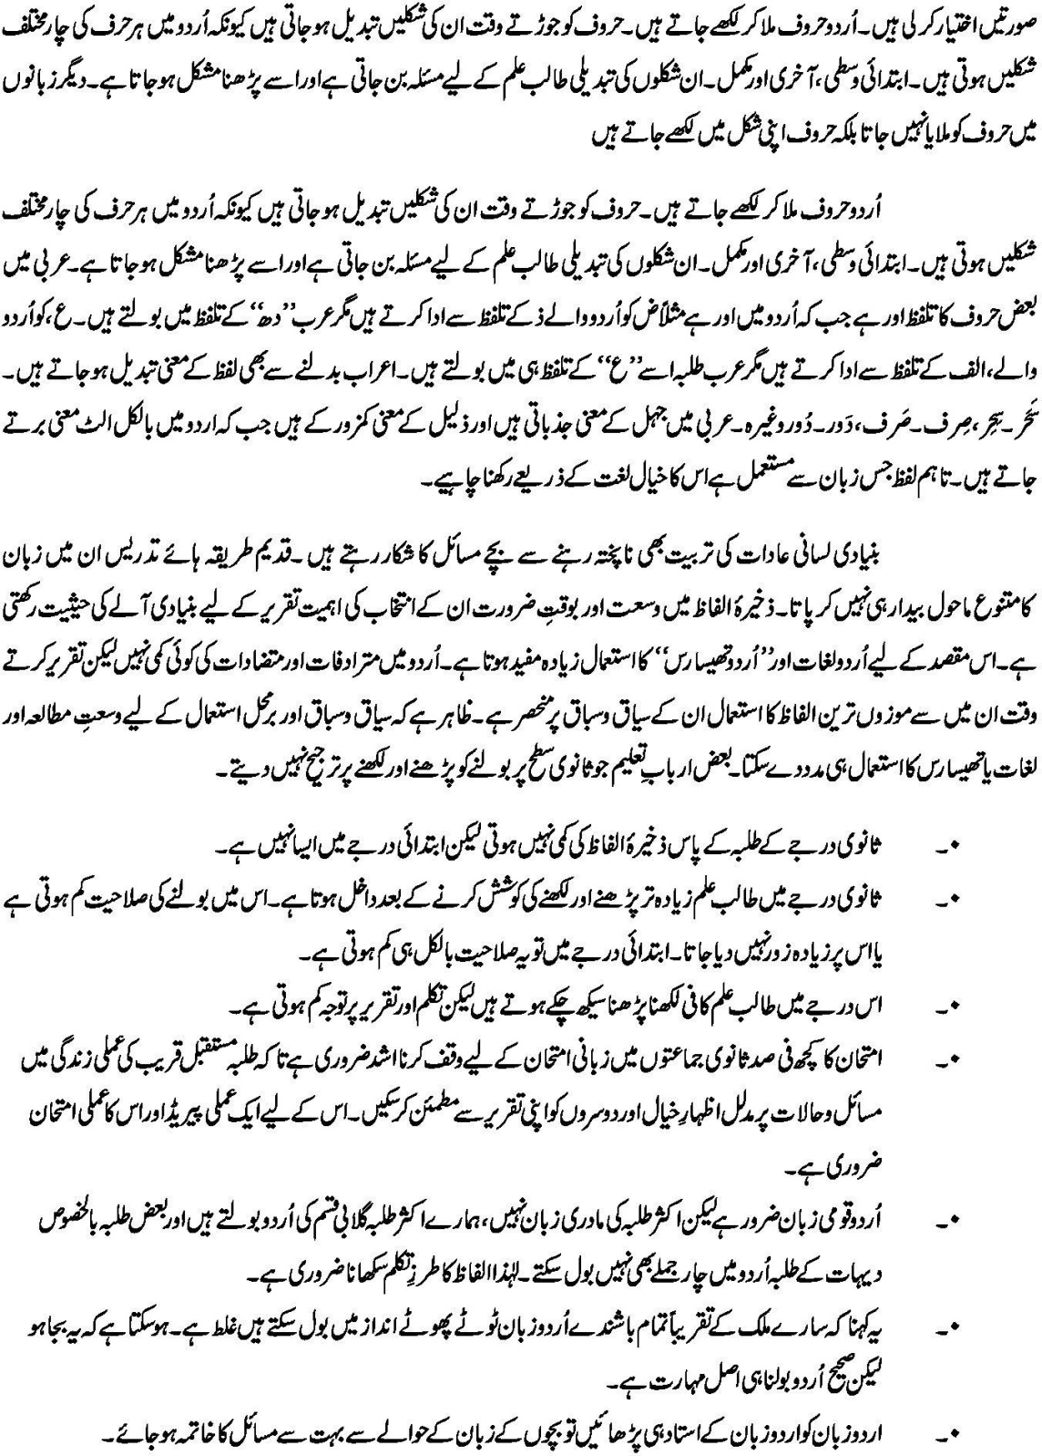

The University of Lakki Marwat
Department of Education & Research

Course Code: EDU:B2311 | Teaching of General Science (Professional) | 3 Credit Hours
BS (4 years) | (3rd Semester)

Objectives
At the end of this course the learners will be able:
- to teach general science effectively at elementary level in an innovative and creative manner.
- Understand scientific concepts.
- Differentiate between scientific products and scientific processes.
- Understand the underlying principles of science education.
- Apply appropriate methods and techniques for effective learning in science.

Unit 1: Nature of Science
  - Definition of Science.
  - Science as a process: Scientific Method.
  - Science as a product: Scientific Knowledge.

Unit 2: Aims/Objective Teaching General Science
  - History of Science Education.
  - Aims/Objective Teaching General Science at elementary level.

Unit 3: Methods of Teaching General Science
  - Demonstration-cum lecture method.
  - Discovery method.
  - Project method.
  - Other Innovative methods.

Unit 4: Approaches of Teaching General Science
- Teaching approach.
- Problem solving.
    - Inquiry techniques.
    - Exploration.
    - Observation.
    - Experiment.
- Teaching strategies.
    - Scope and process of practical activities.
    - Science laboratory.
    - Safety measures in laboratory.

Unit 5: Teaching Aids
- Needs and importance of teaching aids.
- Types of teaching aids.
- Principles of using teaching aids.
- Using low cost teaching aids.

Unit 6: Characteristics of effective Science teaching
  - Characteristic of Lesson planning.
  - Characteristic of science teaching.
  - Effective questioning.

Unit 7: Evaluation
  - Designing a test.
  - Administering and scoring a test.
  - Interpreting test results.

Recommended Books
Lawson, Anton. E. (1995), “Science teaching and development of thinking”, California: Wadsworth publishing company.
Rehman Mehmooda (1999), “Teaching of science and mathematics” Peshawar: Ijaz Printers, Pakistan.

The University of Lakki Marwat
Department of Education & Research

Course Code: EDU:B2312 | Instructional and Communication Technology (ICT) in Education (Professional) | 3 Credit Hours
BS (4 years) | (3rd Semester)

Course objectives:
After completing this course students will be able to:
- Define and describe different ICTs.
- Identify the strengths, and weaknesses of different ICTs.
- Understand different communication technologies
- Understand the modern methods of teaching using ICTs
- Teach different subjects through ICTs
- Understand, apply, and evaluate learning through ICTs

Unit 1: Introduction of ICTs
  - Definition of ICT
  - Traditional and Modern ICTs
  - Strength and weaknesses of ICT’s

Unit 2: Information and communication
  - Data and Information
  - Communication process
  - Types of communication
  - The principles of communication
  - Barriers of communication

Unit 3 : Different types of ICT’s/Aids
  - Graphic Aids/technologies (Charts, Cartoons, diagram, flash cards, graphs, maps, globes, photographs, pictures and posters)
  - Display boards (Black boards, writing boards, Bulletin boards, flannel boards, magnetic boards, electronic boards and peg boards)

Unit 4 : Types and components of computer systems
  - Types of computers
  - The main components of computer systems
  - Safety and Security of data

Unit 5 : Using ICT in Education
  - Using ICT in education
    - ICT in mathematics
    - ICT in Science
    - ICT in Language Lab
  - ICT in evaluation

Unit 6 : Modern Teaching using ICTs
  - Microteaching
  - Teleconferencing in education (Skype)
  - Wikis and Blogs in Education

Unit 7: Communication and networking
  - Modes of data communication
  - Communication channels
  - Elements of network
  - Types of networks

Unit 8 : Role of ICT in professional Growth
  - Lesson planning using ICTs
  - Problems/issues and challenges of using ICTs in education

Recommended Books
Sawyer. W. ( ). Using Information technology : A practical introduction to computer and communications (6th edition), McGraw Hill
Leon, M., and Leon, A. ( ). Fundamentals of Information Technology
Roblyer, M. D. (1999). Integrating technology across the curriculum: A database of strategies and lesson planning
Dickey, E., and Roblyer, M. (1993). Technology in math and science Instruction
Lewis, S. (2004). Using ICT to enhance teaching and learning in chemistry
Mangal, S.K., Mangal, U. (2011). Essentials of educational technology, PHI learning private ltd, New Delhi.
Begum, A. J., Natesan, A. K., Sampath, G. (2011). ICT in Teaching Learning.

The University of Lakki Marwat
Department of Education & Research

Course Code: EDU:B2313 | Teaching Practice (Short Term) | 3 Credit Hours
BS (4 years) | (3rd Semester)

Objectives
Student teachers will be able to:
- Reflect on and learn from teaching practice.
- Collaborate with peers, cooperating teacher and college/ supervisor, establishing professional relationships.
- Invite, accept, and utilize feedback from the supervising teacher, peers, and the college/university supervisor in a non-defensive manner.
- Produce and implement plans for teaching and learning which reflect the use of appropriate instructional methods and strategies to meet the needs of all students within the context of the practicum classroom.
- Utilize appropriate instruments or techniques for assessing student learning and learning needs.
- Recognize cognitive and affective needs of students and establish learning environments and use activities appropriate to meeting those needs.

Course Description
The prospective teachers will be placed in secondary schools for 4 weeks under the supervision of a faculty member. They will teach at actual classroom situation .They will have to prepare 40 lessons for their two optional subjects. The combination is as follow:

Science Subjects: Group A: Physics & Mathematics
Group B: Chemistry & Biology
Arts Subjects: Group A: English & Urdu
Group B: English & Pakistan Studies
Group C: English & Islamiat
Marks: This practical course will carry 100 marks and it will be evaluated by evaluation committee. The evaluation committee composition will be as follow:
- Head of Department
- Head of Teaching Practice School
- DEO male or female

a. School Placement
The practicum experience in Semester 2 should provide secondary grade student teachers with a practicum placement in a secondary classroom.
During the practicum, students are expected to critically select and use appropriate materials, resources (including persons in the community) and technology, and to have experiences with classroom management and a variety of evaluation techniques (including authentic assessment).3 Collaboration with other Student Teachers and professionals in the school setting should be encouraged in order to develop team building skills and utilization of all resources to enhance children's learning. Opportunities for peer coaching as well as coaching by the cooperating teacher and college/university supervisor should be provided.

The University of Lakki Marwat
Department of Education & Research

Course Code: EDU:B2414 | Classroom Assessment (Foundation) | 3 Credit Hours
BS (4 years) | (4th Semester)

Objectives:
After studying this course, the prospective teachers will be able to:
- Understand the concept and nature of assessment.
- Differentiate between standardize and classroom tests.
- Integrate objective with learning assessment.
- Develop and analyze test items of different levels.
- Understand different alternative classroom assessment techniques.
- Interpret test score and results of different assessment techniques.

Unit 1: Concept of Classroom Assessment
  - Distinction between assessment, evaluation and measurement.
  - Purposes of assessment.
  - Comparison between standardized and classroom assessment.
  - Individual and Group assessment

Unit 2: Achievement Tests
- Definition of achievement test.
- Essay type tests.
    - Types of Essay type test.
    - Merits & demerits of Essay type test.
    - Suggestions for improvement.
- Objectives type tests.
- Types of Objective type test.
- Merits & demerits of Objective type test.
- Comparison between Essay type test and Objective type test.

Unit 3: Types of Mental and Educational Tests
  - Speed and power test.
  - Performance test.
  - Ability test, Personality test.
  - Standardized tests and Teacher made test.

Unit 4: Test Construction
  - Planning test construction.
  - Preparing the test items/questions.
  - Assembling the classroom test.
Unit 5: Test Administration and Analysis
  - Administration/Conducting the test.
  - Item Analysis and modification.
  - Purposes of classroom testing.

Unit 6: Interpreting Test Scores
  - Percentage, grades and CGPA.
  - Types of grading
  - Ordering and ranking.
  - Frequency Distribution.
  - Pictorial form (Graph, Polygon, Histogram).

Recommended Books
Ebel, Robert (2004). Essentials of Educational Measurement. India: Prentice hall.
Essa et al, (2005-2006), Educational Measurement & Evaluation, Lahore: Jidran Publications.
Freeman, Richard, (2004). Planning and implementing assessment. New York: Rout ledge Flamer.
George, David (2003). Trends in measurement and Evaluation techniques. New Delhi: commonwealth.
James William (2005). Evaluation and development of School Education. New Delhi: Anmol Publications.
Khan M A (1994), Educational Psychology, Evaluation 7 Guidance, Lahore: Ilmi Kitab Khana.
Kubiszyn, Tom, (2003). Educational testing and Measurement: Classroom Application and practice. United States: John Wiley & Sons, Inc.
Shahid S M (2005), Educational Measurement & Evaluation, Lahore: Majeed Book Depu.
Smith, D, (2005). Theory of Educational Measurement. New Delhi: Common wealth.
Smith, D, (2005). History of Measurement and Evaluation. New Delhi: Common wealth.
Smith, D, (2005). Method of Educational Measurement. New Delhi: Common wealth.
Swain, Sanjaya, (2005). Educational Measurement. Statistics and Guidance. Kalyani Publications.
Thorndike and Hegan(1972), Educational Measurement, New York: Mac Millan.
Usman M (1998), Educational Testing & Evaluation, Lahore: Nadeem Younis Printers.

The University of Lakki Marwat
Department of Education & Research

Course Code: EDU:B2415 | Teaching Literacy Skills (Professional) | 3 Credit Hours
BS (4 years) | (4th Semester)

Objectives:
After reading this subject the students will be able to:
- Use the different activities of development of comprehension.
- Aware of the importance of oral language in literacy.
- Use different activities to develop interest in the use of dictionary.
- Use the principles of teaching and learning for effective literacy skills development.
- Capable to use information technology in their teaching.
- Maintain the balance between different activities.
- Assess their students formative and summative progress

Unit 1: Developing Comprehension Skills
  - Skimming and Scanning
  - Sequencing Activity
    - Goldilocks sequencing
    - Cinderella sequencing
    - Magnifying glass game
    - Magnifying glass sheet
    - Alphabetical order
    - Ordering books
    - Miss out the vowel
    - R A complex activity to develop literacy skills
    - Speech, Spelling and Reading
    - Feeling words

Unit 2: Areas of Literacy Knowledge
  - Oral language to support literacy
  - Choosing vocabulary
  - Types of vocabulary
  - Orthographic and morphemic knowledge
  - Using meta Cognitive and self-management strategies

Unit 3: Dictionary Skills and Reflecting on Reading
  - Dictionary Game
  - Dictionary Search
  - Dictionary Definitions
  - Different Activities to Build up Dictionary Skills
  - Book Review
  - Reading Around the Solar System
  - Bookmark Slogans

Unit 4: Maintaining Balance in Activities
  - Teaching Skills on a Way to Gain Meaning
  - Time Management
  - Guided Instruction
  - Independent Work
  - Use of Construction Activities
  - Effective Integration of Print and Electronic Media
  - Formation Assessment.

Unit 5: Performance assessment for reading
  - Select a Text
  - Work with Scoring Rubrics
  - Some Sample of Rubrics
  - Developing Rubrics
  - Using rubrics for Assigning Grades.

Unit 6: Principles of learning and teaching
  - The Supportive Learning Environment
  - Independent , Interdependent and Self-Motivation
  - Needs and Interest of Student
  - Developing Deep Thinking Levels
  - Learning Connection Practice Beyond the Classroom

Unit 7: Socio economic background and literacy
  - Poverty and Literacy
  - Gender Equity and Literacy
  - Overcoming the Challenge of Diversity
  - Role of Regional Language in Enhancing Literacy
  - Cultural Diversity and Literacy.

Recommended Books
Literacy at National and International Level by S.R. Shah and A.M Plato.
Literacy Biographia Leteriria by Bonkey, M.
Literacy background by Hussain, R.K.H

The University of Lakki Marwat
Department of Education & Research

Course Code: EDU:B2416 | School, Community and Teacher (Foundation) | 3 Credit Hours
BS (4 years) | (4th Semester)

Objectives
Prospective teachers will be able to:
- Analyze and describe relationships between teachers, the school and the families and community that support the school.
- Identify how the teacher’s role is influenced by social and cultural factors that affect education in schools and their communities.
- Recognize and value diverse cultural, traditional and religious values and learning needs of their students in school as well as in their community.
- List the social factors affecting education and how it can support the development of education in the country in general and community in particular.
- Explain his/her role as a role model for their students in school and in the community in general.

Unit 1: Society, Community & Culture
  - Definition of Society & Community.
  - Function and Structure of Society & Community.
  - Characteristics of Culture.
  - Transmission & Transformation of Culture.
  - Culture and Elements of Pakistan Culture.

Unit 2: Groups & Groups Dynamics
  - Meaning and Essentials of Group.
  - Group Dynamics.
  - Types of Social Group.
  - Significance of Group in School System.
  - Role of School & Teacher in molding individual & Group Behavior.

Unit 3: Socialization & Social Institution
  - Definition of Socialization and Social Institution.
  - Role of School and Teacher in Socialization of Individual.
  - Functions & Importance of Socialization.
  - Types of Socialization.
    - The family.
    - Economics institutions.
    - Religious institutions.
    - Political institutions.
    - Educational institutions.
    - Recreational institutions.

Unit 4: Social Change & Social Mobility
  - Meaning of Social change & Social Mobility.
  - Elements of Social change & Social Mobility.
  - Effects of Technologies on Social change.

Unit 5: School & Community
  - Relatives B/W School & Community.
  - Effects of Community on School Teacher.
  - Role of School & Teacher in Development of Community.
  - A critical analysis of role of school and teacher as Pakistani community.

Unit # 6: Social Control
  - Definition of social control.
  - Social conformity and social deviation.
  - Peace, harmony & tolerance.
  - Methods of social control.
  - Role of school and teacher in developing social control.

Recommended Books
There is no standard textbook for this course. The books listed below should be treated as ‘suggested’ readings that can provide support material for both students and the Instructor. Chapters will be assigned chapters when deemed appropriate.
Marshall, L & Rowland, F. (2006). A guide to learning independently, 4th edn, Pearson Longman, French Forest, NSW.
Kotley, S.B, (2008). The Basics of Sociology, Greenwood Press: USA
Bashiruddin, A.& Retallick, J, (eds), (2009). Becoming Teacher Educators, Aga Khan University-Institute of Educational Development: Karachi
Hafeez, S, Pakistani Society,
In addition to the above, the following is a list of suggested (recommended) readings that may be used to supplement class sessions where appropriate:
Abdalla, M.J. & Qureshi, R. (2009). Teacher leadership for school-based professional development: A case study. In Qureshi, R. & Shamim, F.(eds) Schools and schooling practices in Pakistan: Lessons for Policy and Practice, Oxford University Press: Pakistan
Qureshi, R. , Pirzado, P. & Nasim, S. (2007), Schooling in Rural Sindh, Pakistan, In Qureshi, R. & Rarieya, J. (eds), Gender and Education in Pakistan. Oxford University Press: Pakistan, pp.126-146.
Qureshi, R. (accepted for publication). Education for Inclusion: what would it take to have an inclusive primary school in Pakistan?’ Educational Awakening, Journal of the Islamic University Malaysia. 213
Qureshi, R. (2006). Colonial Legacy: Understanding the historical roots of female Illiteracy in Pakistan, Muslim Education Quarterly, vol. 23 (1 & 2): pp.20-37.
Qureshi, R. (2008). Is Child-Friendly School on the agenda for school reforms? Conversations with Pakistani school heads,’ Conference proceedings of the International Conference on the Teacher Education: Transformative Society & Teacher Education Reform, September 19-20,2008, Changchun, China:pp.1-10.
Shaaban, M. & Qureshi, R. (2007) “Teacher leaders: Experiences of Pakistani Teachers in leading school improvement activities.” Conference proceedings of the International Conference on “Quality in Education: Teaching and Leadership in Challenging Times” February 21-23, 2006, Pakistan: Aga Khan University-Institute for Educational Development:.pp.558-564.
Qureshi, R. & Shamim, F.(Eds). (2009). Schools and schooling practices in Pakistan: Lessons for Policy and Practice, Oxford University Press: Pakistan.
Qureshi, R. & Rarieya, J. (Eds) (2007). Gender and Education in Pakistan. Karachi, Pakistan: Oxford University Press: Pakistan. Additional readings will be handed out in class.

The University of Lakki Marwat
Department of Education & Research

Course Code: EDU:B2417 | Teaching of Mathematics (Professional) | 3 Credit Hours
BS (4 years) | (4th Semester)

Objectives
After completion of the course the students will be able to
- Understand numbers and operations.
- Understand Sequence, probability and measurement.
- Learn functions and complex numbers.
- To understand vectors

Unit 1: Number and operations
  - Set definition & operations
  - Prime & Composite Numbers
  - Factors & Multiple
  - Greatest common factor & Least common multiple
  - Division of Whole numbers

Unit 2: Sequence
  - Sequence and its terms
  - Arithmetic sequence
  - Geometric sequence

Unit 3: Probability
  - Sample space and an event
  - Probability definition
  - Problems on probability

Unit 4: Measurement
  - Terminology
  - Units, Tools (instruments), and Precision
  - Linear Measure
  - Area, Volume, Weight, Time, Angle measure

Unit 5: Function
  - Concept of a function
  - Function Notation
  - Various Representations of a function
  - Table
  - Graph
  - Equation
  - Rule (word)

Unit 6: Complex Numbers
  - Complex numbers as ordered pairs of real numbers
  - Graphical representation of complex numbers
  - Solution of equations
Unit 7: Vectors
  - Graphical representation of complex numbers
  - Vectors in plane
  - Vectors in space

Recommended Books
Manual of Objective Mathematics, Concept and Problems by S.M.Rizvi.
Self-tutor Mathematics by B.S.Grawal.
Construction Mathematics by Narinder Kaur Virdi
Mathematical Programming, Theory and Methods by S.M. Sinha.

The University of Lakki Marwat
Department of Education & Research

Course Code: EDU:B2418 | Teaching of Social Studies (Professional) | 3 Credit Hours
BS (4 years) | (4th Semester)

Objectives
By the end of this course the students will be able to:
  - Define Citizenship and describe its key concepts
  - Understand and appreciate the kind of behaviors necessary for the functioning and maintenance of a democratic society
  - Become familiar with the use of active learning pedagogies such as role play, debate discussion, group work and presentations in their classrooms
  - develop and demonstrate the skills to teach controversial issues in their classrooms
  - Develop a respect for human rights including those of individuals and of minorities
  - develop an awareness of the ways in which we learn about the past, and the methods and tools of the historian
  - recognize the interrelatedness of geography, economics, culture, belief systems, and political systems within history
  - discuss how history can be used as a vehicle for processes, knowledge and understanding of Citizenship education
  - understand the concept of culture and how it is transmitted
  - develop an appreciation for the rich complexity of a society’s culture and an understanding of how the parts of a culture interrelate
  - appreciate the similarities and differences that exist among societies of different times and places
  - develop an understanding and appreciation for the rational and peaceful resolution of conflicts and settlement of disputes

Unit 1: Citizenship and Human Rights Education
  - Introduction to the course, Definitions, Rationale for teaching and learning of Citizenship
  - Key Concepts of Citizenship education
  - Controversial Issues—What, Why and How to teach them
  - Towards creating a better world—developing citizenship values, skills and dispositions through the teaching of controversial issues
- Links with other subject areas
- Citizenship rights
  - The Evolution of the concept of Human Rights
    - Rights and Responsibilities, Defining Human Rights
    - Civil, Political, Social, Economic and Cultural Rights
  - Women’s rights, Children’s rights, Interdependence
- Human dignity, Justice, Equality, Freedom,
- Universality, Indivisibility—Are human rights universal?
- Reflection and Review

Unit 2: History - People, Past Events and Societies
    - Definition, Rationale and Methods of History
- Key concepts: Time and Chronology
- Change and Continuity
    - Cause and Effect
- Multiple causation
- Multiple perspectives, Interpretation of history
- Reflection and Review

Unit 3: Geography - People, Place and Environment
  - Definition and Rationale for teaching and learning Geography
- Key Concepts/Themes of Geography: Location, Place, Human-environmental Interactions, Movement, Regions
- Skills required for teaching and learning Geography
  - Global Warming - exploring the issue
    - Global Warming - a myth or reality?
    - Controversy about the theory of, and responses to Global Warming
    - Reflection and Review
  - Global Warming - exploring the issue
    - Global Warming - a myth or reality?
    - Controversy about the theory of, and responses to Global Warming
    - Reflection and Review

Unit 4: Culture and Diversity
  - Rationale for the study of Culture
- The Dynamic Nature of Culture
- Groups and Institutions
  - Society, Socialization
    - Civilization Cultural Adaptation
  - Assimilation, Acculturation
    - Diffusion, Dissonance
    - Multiculturalism and its implications
    - Reflection and Review
  - Interdependence
    - Peace and Sustainability
    - Understanding Peace and Conflict
  - Why ‘Peace Education’, Teaching children the skills to resolve conflicts
    - Positive attitudes and skills—empathy, cooperation, anger-management, and problem-solving
    - Communication and Negotiation
    - Reflection and Review

Unit 5: Power, Authority and Governance
  - Power, Government Systems and Regimes
    - Institutions of Government, political processes and participation
    - Civil society—individuals, groups and institutions
    - Reflection and Review

Unit 6: Production, Distribution and Consumption
  - Definition of and Rationale for teaching and learning of Economics
    - Conflict between wants and resources, Choice, Scarcity
    - Opportunity cost
  - Economic systems
    - Production and distribution of Wealth
    - Supply and demand
    - Reflection and Review

Recommended Books
National Council for the Social Studies Task Force on Standards for Teaching and Learning in the Social Studies. (2008) A vision of powerful teaching and learning in the social studies: Building effective citizens. Social Education, 72(5), 277-280.
Anderson, L. H. (2010). Chains. New York: Athenaeum Books for Young Readers.
Brophy, J. and Alleman, J. (2006). Powerful social studies for elementary students. Belmont, CA: Thomson Wadsworth. 223
Bailey, R. (ed) (2000) Teaching Values and Citizenship Across the Curriculum. London: Kogan Page.
Birzea, C. (2000). Education for democratic citizenship: a lifelong learning perspective. Strasbourg: Council of Europe.
Bridges, D. (1986). Dealing with controversy in the curriculum: A philosophical perspective. In J. Wellington (Ed.), Controversial issues in the curriculum. Oxford, UK: Basil Blackwell.
Citizenship Foundation (2004) ‘Young People are not politically apathetic says new research’. Retrieved October 10, 2006, from http://www.citizenshipfoundation.org.uk/main/news.php?n83.
Citizenship foundation (2006) Controversial issues. Retrieved June 16, 2006, from www. citizenshipfoundation.org.uk/ main/page.php?12.
Clarke, B. (1994) Citizenship: London and Colorado: Pluto Press.
Clough, N & Holden, C. (2002) Education for Citizenship: Ideas into Action. London: Routledge/Flamer
Crick, B. (1998) Education for citizenship and the teaching of democracy in schools. Final report of the Advisory Group on Citizenship.
Crick, B.(2000) Essays on Citizenship. Continuum: London.
David, W. & Cleaf, V. (1991). Actions in elementary social studies. Massachusetts: Allyn and Bacon.
Davies, I. (2005). 100 Ideas for Teaching Citizenship. London: Continuum.
Dean, B. L. & Joldoshalieva, R. (2006). Teaching Controversial Issues: Is it possible in Pakistan.??? (Ed).Unpublished book chapter.
Delanty, G. (2000) Citizenship in a global age: Society, Culture Politics. Buckingham and Philadelphia: Open University Press.
Department for Education and Skills (2004) ‘Introducing Citizenship Education: A guide for parents and carers’. Retrieved October 30, 2006, from
http://www.citizenshipfoundation.org.uk/main/resource.php?s256
Department for Education and Skills (no date) ‘What is citizenship? ‘Retrieved November 20, 2006, from www.dfes.gov.uk/citizenship/section.cfm?sectionId=3&hierachy=1.3
Engle, S. & Ochoa, A. (1988). Education for democratic citizenship: Decision making in social studies. New York: Teachers College Press.
Frazer, E.(2003). Citizenship Education: Anti-political Cultural and Political Education in Britain, in

The University of Lakki Marwat
Department of Education & Research

Course Code: EDU:B2419 | Teaching Practice | 3 Credit Hours
BS (4 years) | (4th Semester)

Objectives
Student teachers will be able to:
- Reflect on and learn from teaching practice.
- Collaborate with peers, cooperating teacher and college/ supervisor, establishing professional relationships.
- Invite, accept, and utilize feedback from the supervising teacher, peers, and the college/university supervisor in a non-defensive manner.
- Produce and implement plans for teaching and learning which reflect the use of appropriate instructional methods and strategies to meet the needs of all students within the context of the practicum classroom.
- Utilize appropriate instruments or techniques for assessing student learning and learning needs.
- Recognize cognitive and affective needs of students and establish learning environments and use activities appropriate to meeting those needs.

Course Description
The prospective teachers will be placed in secondary schools for 4 weeks under the supervision of a faculty member. They will teach at actual classroom situation .They will have to prepare 40 lessons for their two optional subjects. The combination is as follow:

Science Subjects: Group A: Physics & Mathematics
Group B: Chemistry & Biology

Arts Subjects: Group A: English & Urdu
Group B: English & Pakistan Studies
Group C: English & Islamyat
Marks: This practical course will carry 100 marks and it will be evaluated by evaluation committee. The evaluation committee composition will be as follow:

- Head of the Department of Education & Research
- Head of Teaching Practice School
- DEO male or female

a. School Placement
The practicum experience in Semester 2 should provide secondary grade student teachers with a practicum placement in a secondary classroom.
During the practicum, students are expected to critically select and use appropriate materials, resources (including persons in the community) and technology, and to have experiences with classroom management and a variety of evaluation techniques (including authentic assessment).3 Collaboration with other Student Teachers and professionals in the school setting should be encouraged in order to develop team building skills and utilization of all resources to enhance children's learning. Opportunities for peer coaching as well as coaching by the cooperating teacher and college/university supervisor should be provided.

The University of Lakki Marwat
Department of Education & Research

Course Code: EDU:B3520 | Teaching of English (Professional) | 3 Credit Hours
BS (4 years) | (5th Semester)

Objectives
At the end of the course the prospective teacher will be able to be :
- Familiar with the four language skills listening, speaking writing and reading.
- Identify and prepare the activities for developing skills.
- Apply modern methods and approaches in teaching English.
- Prepare lesson plans of prose, poetry composition and Grammar.
- Effective use of audio visual aids.

Unit 1: Four Skills of Language Learning
- listening skills
- Speaking Skills
- Reading Skills
- Writing Skills

Unit 2: Teaching of English
- Teaching of Prose
- Teaching of poems
- Teaching of composition
- Teaching of vocabulary
- Teaching of pronunciation

Unit 3: Methods of teaching English
  - Grammar: Translation method
  - Direct method
  - Audio-Lingual Approach
  - Structural Approach
  - Communicative Approach
  - Word Building

Unit 4: Lesson Planning
  - Importance of activities in all kinds of lessons
  - Value of different steps in Lesson Planning
  - New teaching approaches; activity based.
  - Planning structural lessons
  - Planning a Prose and Poetry Lesson
  - Planning a Paragraph, Story and an Essay
  - Planning a Grammar Lesson

Unit 5: A.V Aids in Teaching of English
  - Need and Importance
  - Charts, Models, Pictures, Role plays Flash cards, Toys and Real Objects
  - Radio, Cassette player, Language Laboratory
  - Television, VCR, Movies
  - Slides, Filmstrip, OHP, Multimedia projector

Unit 6: Assessment
  - Construction of objective type test.
  - Construction of essay type test.

Recommended Books
Cook V. (1991). Second Language Learning and Language Teaching, 2nd ed. London, Arnold.
Mohammad.T. (1998). Modern Approaches to the Teaching of English as Second language, Lahore: Majeed Book Depot.
Murcia, M.C. (1991), Teaching English as Second Foreign Publishers.
Rob Nohand (1993). Conversation, London: Oxford University Press.
Sheikh. N.A. (1998). Teaching of English as a Second Language. Lahore: Caravan Book House.

The University of Lakki Marwat
Department of Education & Research

Course Code: EDU:B3521 | Foundations of Education (Foundation) | 3 Credit Hours
BS (4 years) | (5th Semester)

Objectives
After completion of the course student will be able to know abort:
- Meaning of education.
- Relationship of philosophy to education.
- Factor effecting education in Pakistan.

Unit 1: Introduction
  - What is education?
  - Aims of education
  - Historical perspective of education.
  - The relationship of education to other social sciences.

Unit 2: Philosophical Development of Education
- Meaning of educational philosophy
- Ontology, epistemology and axiology in education.
- Instrument of knowledge
- Scientific knowledge and philosophy

Unit 3: Philosophies of Education
- Naturalism
- Idealism
- Pragmatism
- Realism

Unit 4: Contribution of Following Philosophies to Education
- Progressivism
- Perennialism
- Essentialism
- Re-constructionism

Unit 5: Sociology of Education
- Meaning of sociology of education
- Culture and education
- Society and education
- School as a social institution

Unit 6: Education and Human Psychology
- Relevance of psychology to education
- Role of motivation in education.
- Development of positive attitude
- Factors affecting personality

Unit 7: Islamic Foundations of Education
- Meaning and importance of education in Islam.
- Sources of knowledge in Islam.
- Quran
- Hadith
- Qiyas
- Fiqa
- Islamic education in historical perspective

Unit: 8: Factors affecting Education in Pakistan
- Foreign language.
- Polities
- Teacher
- Home

Recommended Books
Bases of Islamic culture by Syed Abdul Latif
Culture and Education by Lawrence Sten house.
Foundation of education by Joseph-Feallahan-Leanard
Foundation of Teaching and Learning by Robert R-Dun-Well and Robert-L-Wendal
History of Islamic Philosophy by Majid Fakhry
The Challenges of Islamic Renaissance by Syed Abdul Qadus
The Sociology of Education by Ivor-Morrish
Land marks in the history of education by T.L.Jarma
Social Foundation of education by Dorothy-West by Gibson

The University of Lakki Marwat
Department of Education & Research

Course Code: EDU:B3522 | Physics-I (Science Group) | 3 Credit Hours
BS (4 years) | (5th Semester)

Objectives
This course is aimed at:
- To provide Basic information about teaching of Physics.
- To enhance understanding of students regarding teaching of physics.
- To improve Prospective teachers’ skill for teaching of Physics
- To familiarize Prospective Teachers with the fundamental principles, theories and concepts of physics.

Unit 1: Introduction to Teaching of Physics
  - Philosophy of teaching of Physics
  - Effect of Physics on our daily life
  - Science as a process: Scientific method
  - History of teaching of physics
  - Branches of Physics

Unit 2: Aims and Objectives of Teaching of Physics
  - Aims of Teaching Physics
  - Bloom’s taxonomy of teaching objectives
  - Techniques for developing scientific attitude
  - Role of Physics Teacher
  - Using Aims and objectives to guide student learning

Unit 3: Methods of Teaching Physics
  - Lecture method
  - Lecture demonstration method
  - Laboratory method
  - Project method
  - Discovery method
  - Problem solving method
  - Discussion method

Unit 4: Audio-Visual Aids
  - Concept and definition of teaching Aids.
  - Need and importance of AV Aids in Physics.
  - Types of teaching aids (Projected aids, Non-Projected aids)
  - Principles of using teaching aids
  - Using low cost teaching aids.

Unit 5: Management of Science Laboratory
  - Staffing
  - Furniture, equipment and instrument for science laboratory
  - Guidelines in preparing lists of requirements
  - Inspection and maintenance of laboratory equipment
  - The Physics Laboratory
  - General laboratory safety and techniques
Unit 6: Teaching Strategies in Science Lab
  - Controlled exercise
  - Experimental investigation
  - Research Projects

Unit 7: Lesson Planning
  - Importance of Lesson planning
  - Principles of Lesson Planning
  - Steps of Lesson Planning

Recommended Books
Aftab Ahmad Shekih et.al Physics for IX. Classes, N.W.F.P. Textbook Board Peshawar.
Tirimzi S.M.A et al Fundamental of Physics Vol: 18th Edition “Punjab Textbooks Board Lahore.
Khan M.A. “An easy approach to intermediate Physics” 1996-97 Edition, Ilmi Kitab Khana Kair Street, Urdu Bazar Lahore-2.
Shah Dr. M.A “Electricity and Magnetism” for B.Sc students, Ilmi Printing Press, 17, Hospital Road Lahore.
BS “Tradress-e-Science” A.I.O.U Islamabad.
Carin, Arthur A., and Sund, Robert B. Teaching Science through Discovery Charles, E. Merrill Publishing Co. Columbus Oheo 1970.
Richardson John, s “Science Teaching in Secondary Schools, Prentice Hall Inc Cliffs N.J 1957.

The University of Lakki Marwat
Department of Education & Research

Course Code: EDU:B3523 | Computer Science-I (Arts Group) | 3 Credit Hours
BS (4 years) | (5th Semester)

The University of Lakki Marwat
Department of Education & Research

Course Code: EDU:B3524 | Chemistry-I (Science Group) | 3 Credit Hours
BS (4 years) | (5th Semester)

Objectives
After completion of this course the students will be able to:
- Understand scientific concept
- Differentiate between scientific product and scientific processes
- Understand and underlying principles of teaching of chemistry
- Apply appropriate methods and techniques for effective learning in teaching of chemistry
- State the objectives in behavioral term
- Know the basic concept of chemistry

Unit 1: Introduction
  - Pedagogical skills and its application for chemistry
  - Application of chemistry in daily life
  - Development and advancement in the field of chemistry

Unit 2: Objectives
  - Differentiation between Aims Goals and objectives
  - Blooms Taxonomy of objectives
  - Formulation of objectives for chemistry at elementary level

Unit 3: Strategies of teaching chemistry
  - Lecture-Demonstration method
  - Problem solving method
  - Experimental method
  - Micro-teaching
  - Co-operative learning method
  - Activity based learning techniques in teaching of chemistry

Unit 4: Teaching Aids
  - A.V. aids and their functions in teaching of chemistry
  - Merits and Demerits of traditional and modern Audio visual aids
  - Use and impacts of computer and technology in teaching of chemistry at elementary level
  - Organization of apparatus of chemicals in a chemistry laboratory.
  - Laboratory Rules and precaution

Unit 5: Lesson Planning
  - Lesson planning and its impotence
  - Characteristics of a lesson plan
  - Lesson plans of chemistry from secondary school level

Unit 6: Evaluation
  - Evaluation and its concept
  - Types of evaluation
  - Formulation of objective and essay type test from chemistry curriculum

Unit 7: Periodic Table
  - Different types of elements of periodic table
  - Distribution of electrons, valence shell configuration
  - Arrangement of elements in periodic table

Unit 8: Acid, Bases and Salts
  - Properties and uses of acids
  - properties and uses of bases and salts
  - PH and its Range (1-14)
  - Natural indicators

Unit 9: Properties of Elements
  - Physical properties of different elements in periodic table
  - Chemical properties and relativities of different elements in periodic table

Recommended Books
Interactive Organic Chemistry by Girjish Dubey 2002
Basic Chemistry by Karen, C. 2000.
Introductory Chemistry by Ram, T Chand, 1999.

The University of Lakki Marwat
Department of Education & Research

Course Code: EDU:B3525 | English-I (Arts Group) | 3 Credit Hours
BS (4 years) | (5th Semester)

Objective
- Enable students to:
- Enhance language skills
- Develop critical thinking
- Know about basics of grammar
- Learn comprehension skills
- Understand discussion and listening skills
- Develop translation skills and paragraph writing

Unit 1: Basics of Grammar
- Parts of speech and use of articles
- Sentence structure, active and passive voice
- Practice in unified sentence
- Analysis of phrase, clause and sentence structure
- Transitive and intransitive verbs
- Punctuation and spelling

Unit 2: Comprehension
- Definition of comprehension
- Key tips of writing comprehension
- Development of comprehension
- Answers to questions on a given text

Unit 3: Discussion
- General topics and every-day conversation (topics for discussion to be at the discretion of the teacher keeping in view the level of students)

Unit 4: Listening
- Definition of listening
- Types of listening
- How to be a good listener?

Unit 5: Translation Skills
- Urdu to English
- English to Urdu

Unit 6: Paragraph Writing
- Definition of paragraph
- Types of paragraphs
- Development of paragraph writing

Unit 7: Presentation Skills
- Definition of Presentation
- Preparation of Presentation through power Point
- Development of Presentation skills.
Recommended Books
Practical English Grammar by A.J. Thomson and A.V. Martinet. Exercises 1. Third edition. Oxford University Press. 1997. ISBN 0194313492
Practical English Grammar by A.J. Thomson and A.V. Martinet. Exercises 2. Third edition. Oxford University Press. 1997. ISBN 0194313506
Writing. Intermediate by Marie-Christine Boutin, Suzanne Brinand and Francoise Grellet. Oxford Supplementary Skills. Fourth Impression 1993. ISBN 0 19 435405 7 Pages 20-27 and 35-41.
Reading. Upper Intermediate. Brain Tomlinson and Rod Ellis. Oxford Supplementary Skills. Third Impression 1992. ISBN 0 19 453402 2.

The University of Lakki Marwat
Department of Education & Research

Course Code: EDU:B3526 | Curriculum Development (Foundation) | 3 Credit Hours
BS (4 years) | (5th Semester)

Objectives
- At the end of the course, the students will be able to:
- Understand the concept of curriculum
- Aware about the process of curriculum development in pakistan
- Examine the components of curriculum development
- Differentiate between different types of curriculum
- Write curriculum objectives in behavioral terms
- State the critical issues, problems and trends in curriculum

Unit 1: Introduction to Curriculum
  - The definition of Curriculum
  - Various forms of Curriculum
  - Elements of Curriculum: Objectives, Content selection, Curriculum implementation, evaluation of curriculum.
  - Learning experiences and assessment of students learning

Unit 2: Foundations of Curriculum
- Philosophical
- Psychological
- Sociological

Unit 3: Curriculum: Aims, Goals and Objectives
- Distinction between aims, goals & objectives
- Taxonomies of educational objectives
- Cognitive domain
- Affective domain
- Psychomotor domain
- Solo Taxonomy of educational objectives

Unit 4: Models of Curriculum
- Tyler Model
- Wheeler Model
- Dynamic Model
- Skel Beck Model

Unit 5: Designs of Curriculum
- Subject-based
- Activity-based

Unit 6: Process of Curriculum Development in Pakistan
- Curriculum development at elementary and secondary level
- Role of teacher in curriculum development process at various levels

Unit 7: Curriculum Change
- Process of Curriculum Change
- Various issues in Curriculum change

Recommended Books
Beane I.A, Toefer C.F & Alessi S.J (1986). Curriculum Planning & Development. Boston and Bacon.
Farooq, R.A. (1993). Education system in Pakistan. Islamabad: Asia Society for the Promotion of Innovation and Reforms in Education.
Kelley A.V (1999). The Curriculum: Theory and Practice. London. PaulChapman.
McNeil J. D (1990). Curriculum: A Comprehensive Introduction, (4th.ed) Los Angeles: Harper Collins
Murray P. (1993). Curriculum Development & Design, (5th ed),
Sharma R.C (2002). Modern Methods of Curriculum Organization. New Delhi:

The University of Lakki Marwat
Department of Education & Research

Course Code: EDU:B3527 | Educational Psychology (Foundation) | 3 Credit Hours
BS (4 years) | (5th Semester)

Objectives
After completion of this course, the students will be able to:
- Apply principles of psychology in class room settings
- Discover the new avenues of classroom teaching on the basis of psychological theories better teaching-learning situation.
- Solve classroom problems using principles of learning.
- Understand motivation and strategies to increase motivation in the classroom.

Unit 1: Introduction
  - Definition of educational psychology
  - Relationship of psychology to education
  - Scope/usefulness of psychology

Unit 2: Child Development
- An overview of Growth and Development
- Stages of physical Development
- Principles of Child Development

Unit 3: Cognitive Development
- The Brain
- Piaget’s Theory
- Vygotsky’s Theory

Unit 4: Learning
- Definition of learning
- Theories of learning
- Factors effecting learning

Unit 5: Motivation
- Theories of motivation
- Factors affecting motivation
- Techniques of motivation

Unit 6: Individual Differences
- Concepts of individual differences
- Types of individual differences

Unit 7: Intelligence
- Definition of intelligence
- Measurement of Intelligence

Unit 8: Personality
- Origins of Personality/ Personality development.
- Theories of personality (Psychoanalytic theory & Trait theories)

Recommended Books
Arbuckle, D.S. (1961).Guidance and Counseling in the Classroom . Boston: Allyn &Bacaon.Gibon, R.L. and Mitchel M.H. (1999).
Introduction to Counseling and Guidance . NewJersey: Prentice HallSantrock J. W. (2006).
Educational Psychology, McGraw-Hill Company.Skinner, C. E. (2006).
Educational Psychology. New Delhi: Prentice- Hall.Woolfolk, C. (2006).
Educational Psychology . New York: Allyn and Bacon.
Fontana, D. (1988) Psychology for Teachers, 2nd edition, England: The British
Psychological Society in collaboration with Macmillan Publishers.
Child, D. (1993). Psychology and the Teacher, 5th Edition London: Cassell.

The University of Lakki Marwat
Department of Education & Research

Course Code: EDU:B3628 | Contemporary Issues and Trends in Education (Professional) | 3 Credit Hours
BS (4 years) | (6th Semester)

Objectives
Unit 1: Education as a Complex Enterprise
  - Meaning and aims of education
  - Function of education
  - Formal, Informal and non-formal education
  - Barriers of education
  - Factors affecting education

Unit 2: Problems and Issues in Education
- The various role of teacher (Social role, Professional role & Ideological role)
- Status of teacher in Pakistan
- The privatization of education (meaning)

Unit 3: Technology and Education
- Globalization
- Importance of technology in education
- Use of technology in classroom teaching
- Advantage and disadvantage of ICT in education

Unit 4: Gender Equality in Terms of Education
- Education as a basic human right (irrespective of gender, class etc.
- Girls education/women education
- The role of educated mother

Unit 5: Introduction to Peace Education
- The role of peace education
- Conflicts in school (tolerance, bullying, violence)
- Conflicts resolution at school level
- The impact of peace issues on education

Unit 6: Role of School in Addressing Contemporary Issues
- The need for schools to create active citizens
- The role of schools in producing workers and professionals
- The role of schools in imparting democratic education
- The importance of character education and skills development
- Factors affecting the quality of schooling
- Issues faced by schools

Unit 7: Problems and Issues of Teacher Education
- Issues and problems of teacher education
- Suggestion and recommendations
- How to prepare teacher for tomorrow (Pre service courses, In-service provision, Supervise & Professional excellence)

Recommended Books
Buzan, Tony, The Power of Creative intelligence, Martins the printers Ltd., UK, 2001.
Coombs, Philip, H. The World Crises in Education, Oxford University press, New York, 1985.
Farooq, R.A. Education System in Pakistan, Asia Society for Promotion of Innovation and Reforms in Pakistan, Islamabad.
Mukerjea, Dilip, Super Brain Singapore Oxford University Press1996
UNESCO, Literacy Trends in Pakistan, Islamabad, 2004.
Pakistan, Government of, National education Policy 1998-2010, Islamabad.
Rose, Colin and Malcolm J. Nicholl, Accelerated Learning for the 21st Century, Dlacoste Press, USA,1997.
Traverso, Adriano, Buzzati, The Scientific Revolution: Today and Tomorrow, Unesco,Paris 1977.

The University of Lakki Marwat
Department of Education & Research

Course Code: EDU:B3629 | Physics-II (Science Group) | 3 Credit Hours
BS (4 years) | (6th Semester)

Objectives:
After completion of this course, the students will be able to:
- Describe the interdependence of ecosystems and the organisms within and how changes affect populations and the equilibrium of a system. Relate evolutionary forces to the diversity of ecosystems and of the species within them
- Identify the effects of human activities and naturally occurring changes on ecosystems and the consequences of those changes
- Begin to see the Earth as a system consisting of major interacting components that consistently undergo change. Physical, chemical, and biological processes act within and among them on a wide range of timescales
- Describe physical and chemical properties and physical/chemical processes with a special focus on the change of state of matter and how this change relates to energy
- develop an understanding of common misconceptions about matter and particle theory
- Describe a chemical reaction in the context of a rearrangement of atoms and also in the context of the formation of a new substance with new properties
- Investigate the relationships among force, mass, and motion of an object or system
- Apply various models to science teaching while recognizing their limitations. Prevent potential misconceptions that could result from the use of some widely used models

Unit 1: Introduction to Physics
- Definition and nature of physics
- Branches of Physics
- Importance of physics
- Role of physics in education
- Uses of physics in daily life
Unit 2: Vectors and Equilibrium
- Definition of vectors and equilibrium
- Addition of vectors
- Representation of vectors
- Conditions of equilibrium
- conditions of equilibrium and dimensional problems
Unit 3: Properties of matter
- Physical properties of matter, including melting point, boiling point, hardness, density, and conductivity
- Atoms, molecules, mixtures, elements, and compounds
- Introduction to the periodic table
- States of matter: solid, liquid, gas (examples of water)
- Introduction to models and their limitations in science teaching
- Teaching ‘properties of matter’ in elementary grades

Unit 4: Populations and ecosystems
- Basic needs of living things
- Interdependencies of living things (symbiotic relationships)
- Ecosystems and habitats
- Population growth: survival and extinction

Unit 5: Diversity and adaptations
- Diversity of living things
- Systems of classification
- Adaptations for survival
- Evolution and diversity
- Teaching ‘diversity and adaptations’ in elementary grades

Unit 6: Earth: The blue planet
- Earth: an inhabitable planet
- Weather and seasons
- Categorizing the world by continents, biomes, vegetation zones, climate zones, etc.
- Introduction to maps; reading and creating simple data charts
- Constant changes on Earth: rock cycle
- Rivers (erosion/sedimentation)
- Earthquakes and volcanoes

Unit 7: Force and motion
- Relationship among force, mass, and motion of an object
- Interaction of objects as it relates to force and linear, constant motion
- Graphing of motion and basic calculations of speed and average speed
- Non-linear motion and accelerated motion (laws of motion)
- Graphing of non-linear and accelerated motion
- Teaching ‘force and motion’ in elementary grades

Unit 8: Work and Energy
- Definition of work and energy
- Relationship of work and energy
- Conservation of energy
- Sources of energy
- Work done in gravitational field

Recommended Books
Target Science: Physics by Stephen Pople
Target Science: Chemistry by Michael Clugston and Rosalind Fleming
The Teaching of Science in Primary Schools by Wynne Harlen
Inquiry: Thoughts, Views, and Strategies for the K–5 Classroom – National Science Foundation
Ready, Set, Science! Putting Research to Work in K–8 Science Classrooms – National Research Council
Taking Science to School: Learning and Teaching Science in Grades K–8 – National Research Council
The University of Lakki Marwat
Department of Education & Research

Course Code: EDU:B3630 | Computer Science-II (Arts Group) | 3 Credit Hours
BS (4 years) | (6th Semester)

Objectives
After studying this course, the students will be able to:
- Define computer terminology
- Identify the basic components of a computer and describe the function of each.
- Use the keyboard to interact with the computer
- Describe different applications of computers in education.
- Develop skills to use computer in educational settings.
- Communicate through computer with friends, and teachers in and outside the country.
- Use computer for research, data analysis and presentations

Unit 1: Introduction
  - Definition and Importance of Computer
  - Basic Concepts of the Computer Hardware
  - Input and Output Devices
  - Functions of Computer

Unit 2: Computer Software
- Concept of Software
- Types of Software
- Applications of Computer in Education

Unit 3: Word Processing and Document Handling
- Creating, Saving and Opening a Document
- Composing and editing Educational Documents
- Inserting and resizing tables, pictures and shapes
- Line Spacing, paragraphing and formatting text
- Page Setup and Printing document

Unit 4: Spreadsheet (Excel)
- Features of M.S. Excel
- Sum/Subtractions/Multiplication/division/Percentage/ Average/ If statement
- Sorting and Filtering Data
- Inserting Charts and Graphs

Unit 5: PowerPoint
- Composing Presentations
- Delivering Presentations

Unit 6: Internet and Information Highways
- Network, Types of Network, Server and Client
- Internet, World Wide Web, Search Engines, Internet Browser
- E-Mail Management
- Online Educational Resources
- Educational databases
Unit 7: Computer Based Instructions
- Computer Based Instructions: an introduction
- Computer Assisted Instruction
- Computer Based Assessment

Unit 8: Course Evaluation
- Assignments 20
- Mid Semester Test 25
- Final Project 15
- Final Test 40
- Total 100

Recommended Books
Faden, P.D., and Vogel, R.M. (2003). Methods of Teaching, Boston: Mc-Graw Hills.
Joyce, B., Weil M., and Calhoun, E. (2000). Models of Teaching, 6th ed. Boston: Allyn and Bacon.
Norton, P. (2000). Introduction to Computers 5th ed; New York: Mc-Graw Hill Book Co.
Norton, P. (2003). Introduction to Computers, 5th ed., New York: McGraw-Hill Book Co.
Norton, P., & Spragu, D. (2001). Technology for Teaching, Boston: Allyn and Bacon.
Sharma, A. (1999). Modern Educational Technology, New Delhi: Prentice-Hall.
Sharma, S. R. (2000). Effective Classroom Teaching Modern Methods, Tools and Techniques. Jaipur: Mangal Deep Publications.
Shelly, G. B. & Vermaat, M. E. (2008). Discovering Computer. Pakistan: Book Media

The University of Lakki Marwat
Department of Education & Research

Course Code: EDU:B3631 | Zoology-I (Science Group) | 3 Credit Hours
BS (4 years) | (6th Semester)

Objectives
After studying this course, the students will be able to:
- Learn about the biological molecules
- Understand the cell classification and nutrition
- Enable them to understand the significance of zoology in life.

Unit 1: Biological Molecules
  - Branches and importance of Zoology
  - Carbohydrates
  - Proteins
  - Lipids

Unit 2: Nutrition
- Balanced diet
- Malnutrition and Diseases

Unit 3: The Cell
  - Composition of Cell, Structure
  - Function of all organelles
  - Bacteria/ Viruses
  - Bacterial and Viral Diseases

Unit 4: Classification
- Basic unit of Classification/ Kingdom systems
- Carolus Linneaus concept
- Protozoa/ Porifera
- Coelentrata/ Platyhelminthes/ Nematodes
- Annelids/ Molluscs
- Arthropods/ Echinoderms

Recommended Books
Molecular Biology of the Cell by Bruce Alberts
The Cell: A Molecular Approach by Geoffrey, M. Cooper
Essentials of nutrition and diet therapy by Eleanor, D. Schlenker

The University of Lakki Marwat
Department of Education & Research

Course Code: EDU:B3632 | Islamyat-I (Arts Group) | 3 Credit Hours
BS (4 years) | (6th Semester)

Objectives
This course is aimed at:
  - To provide Basic information about Islamic Studies
  - To enhance understanding of the students regarding Islamic Civilization
  - To improve Students skill to perform prayers and other worships
  - To enhance the skill of the students for understanding of issues related to faith and religious life.

Unit 1: Introduction to Quranic Studies
- Basic Concepts of Quran
- History of Quran
- Uloom-ul -Quran

Unit 2: Study of Selected Text of Holly Quran
- Verses of Surah Al-Baqra related to Faith (Verse No-284-286)
- Verses of Surah Al-Hujrat related to Adab Al-Nabi (Verse No-1-18)
- Verses of Surah Al-Mumanoon related to Characteristics of faithful (Verse No-1-11)
- Verses of Surah al-Furqan related to Social Ethics (Verse No.63-77)
- Verses of Surah Al-Inam related to Ihkam(Verse No-152-154)

Unit 3: Study of Selected Text of Holy Quran
- Verses of Surah Al-Ihzab related to Adab al-Nabi (Verse No.6, 21, 40, 56, 57, and 58)
- Verses of Surah Al-Hashar (18,19,20) related to thinking, Day of Judgment
- Verses of Surah Al-Saf related to Tafakar,Tadabar (Verse No-1,14)

Unit 4: Seerat of Holy Prophet (S.A.W)
- Life of Muhammad Bin Abdullah ( Before Prophet Hood)
- Life of Holy Prophet (S.A.W) in Makkah
- Important Lessons derived from the life of Holy Prophet in Makkah

Unit 5: Seerat of Holy Prophet (S.A.W) II
- Life of Holy Prophet (S.A.W) in Madina
- Important Events of Life Holy Prophet in Madina
- Important Lessons Derived from the life of Holy Prophet in Madina

Unit 6: Introduction to Sunnah
- Basic Concepts of Hadith
- History of Hadith
- Kinds of Hadith
- Uloom –ul-Hadith
- Sunnah & Hadith
- Legal Position of Sunnah
Unit 7: Introduction to Islamic Law & Jurisprudence
- Basic Concepts of Islamic Law & Jurisprudence
- History & Importance of Islamic Law & Jurisprudence
- Sources of Islamic Law & Jurisprudence
- Nature of Differences in Islamic Law
- Islam and Sectarianism

Unit 8: Islamic Culture and Civilization
- Basic Concepts of Islamic Culture & Civilization
- Historical Development of Islamic Culture & Civilization
- Characteristics of Islamic Culture & Civilization
- Islamic Culture & Civilization and Contemporary Issues

Unit 9: Islam and Science
- Basic Concepts of Islam & Science
- Contributions of Muslims in the Development of Science
- Quranic & Science

Unit 10: Islamic Economic System
- Basic Concepts of Islamic Economic System
- Means of Distribution of wealth in Islamic Economics
- Islamic Concept of Riba
- Islamic Ways of Trade & Commerce

Unit 11: Unit Political System of Islam
- Basic Concepts of Islamic Political System
- Islamic Concept of Sovereignty
- Basic Institutions of Government in Islam

Unit 12: Islamic History
- Period of Khlaft-E-Rashida
- Period of Ummayyads
- Period of Abbasids

Unit 13: Social System of Islam
- Basic Concepts of Social System Of Islam
- Elements of Family
- Ethical Values of Islam

Recommended Books
Ahmad Hasan, (1993), “Principles of Islamic Jurisprudence” Islamic Research Institute: Islamabad: Pakistan, International Islamic University.
Bhatia, H. S. (1989) “Studies in Islamic Law, Religion and Society” New Delhi: Deep & Deep Publications.
Dr. Muhammad Zia-ul-Haq, (2001). “Introduction to Al Sharia Al Islamia” Islamabad, Pakistan: Allama Iqbal Open University.
Hameed ullah Muhammad, ‘Introduction to Islam Mulana Muhammad Yousaf Islahi,”
Hameed ullah Muhammad, “Emergence of Islam” , Islamabad: IRI.
Hameed ullah Muhammad, “Muslim Conduct of State” Islamabad, Pakistan: Hussain Hamid Hassan, u leaf Publication.

The University of Lakki Marwat
Department of Education & Research

Course Code: EDU:B3633 | Comparative Education (Professional) | 3 Credit Hours
BS (4 years) | (6th Semester)

Objectives
After studying this course, the students will be able to:
      - Describe the meaning and significance of comparative education.
      - Compare the education system of selected developed countries.
      - Compare the education system of selected developing countries.
      - Analyze critically the education system of Pakistan.

Unit 1: Introduction to Comparative Education
  - Concept of comparative education-meaning need and scope.
  - Purposes of comparative education.
  - Methods of Comparative education.

Unit 2: Elements of Comparative Education (Both Qualitative and Quantitative Dimensions)
- Objectives
- Curricula
- Teaching methodology.
- Assessment and Evaluation (Students achievement, examination system)
- Facilities
- Educational structure
- Administrative and financial set up
- Teacher Education

Unit 3: Comparative View of Systems of Education in Pakistan
- Private and Public
- Madarasah and formal Education
- Formal vs Distance and non-formal education

Unit 4: Comparative Education in Developed Countries
- USA
- UK
- Japan
- Singapore

Unit 5: Comparative Education in Developing Countries
- India
- China
- Malaysia
- Pakistan

Unit 6: Global Issues in Comparative perspective (Focusing Developing Countries)
- Quality Education
- Education for all
- Recruitment of teachers at elementary and secondary level
- Admission procedure at higher education level

Recommended Books
Isani, and Virk, ML (2006) Higher Education in Pakistan, Islamabad, National Book Foundation.es:

The University of Lakki Marwat
Department of Education & Research

Course Code: EDU:B4734 | Introduction to Guidance and Counselling (Professional) | 3 Credit Hours
BS (4 years) | (6th Semester)

Objectives
On successful completion of this course learners will be able to:
- Demonstrate knowledge of the importance of guidance and counselling to support the teacher’s role in the classroom.
- Explain the role of various members of a guidance and counselling system in supporting learners in addressing their future choices and social challenges.
- Demonstrate the skills of student’s advisement in making responsible social choices and decisions.
- Assist students in making informed choices to solve personal educational and social problem they confront.
- Refer students to resources that can assist them in solving social and personal problems they encounter.

Unit 1: Introduction to Guidance and Counseling
- Define and differentiate Guidance and Counseling.
- Objectives of Guidance
- Principles of Guidance
- List the various members of a counseling team and explain their responsibilities.

Unit 2: The role of Guidance and Counseling Personnel
- Teacher in Guidance and counseling
- Psychologist in student services
- Administrators in Guidance and counseling
- Career counselor
- Librarian in Guidance and Counseling

Unit 3: Techniques of Guidance and Counseling Personnel
- How the teacher can assist the learner to make informed choices to guide their future
- Assisting the learner in personal and social development
- Developing guidance skills: questing techniques, active listening

Unit 4: Basic Skills of Counseling
- Identifying elementary social problems the classroom teacher can resolve
- Exercising basic counseling skills in a controlled situation
- Evaluating basic counseling techniques among peers

Unit 5: Services of Guidance
- Orientation service
- Testing service
- Educational and occupational services
- Counseling services
- Placement services.
- Follow-up services.
- Research and Evaluation Services.

Unit 6: Evaluation of the Guidance Program
- Types of evaluation in guidance and counseling program
- Program evaluation

Unit 7: Evaluation of the Guidance Program
- Nature and the purposes of cumulative record card (CRC)
- Advantages of the CRC
- Design of CRC

Recommended Books
Kochar. S.K (2000) Guidance and Counseling in College and Universities. Sterling Publishers Private Limited, Green Park, New Delhi.
Fullmer. D.W (1977), Bernard. H.W Principles of Guidance, 2nd Edition, Thomas Y.Crowell COmpay, New York.
Standford. S, Pietrofera.J.J. Guidance and Information. R and MC Nally, College Publishing Company, USA.

The University of Lakki Marwat
Department of Education & Research

Course Code: EDU:B4735 | Teaching Practice (Short Term) | 3 Credit Hours
BS (4 years) | (6th Semester)

Objectives
Student teachers will be able to:
- Reflect on and learn from teaching practice.
- Collaborate with peers, cooperating teacher and college/ supervisor, establishing professional relationships.
- Invite, accept, and utilize feedback from the supervising teacher, peers, and the college/university supervisor in a non-defensive manner.
- Produce and implement plans for teaching and learning which reflect the use of appropriate instructional methods and strategies to meet the needs of all students within the context of the practicum classroom.
- Utilize appropriate instruments or techniques for assessing student learning and learning needs.
- Recognize cognitive and affective needs of students and establish learning environments and use activities appropriate to meeting those needs.

Course Description
The prospective teachers will be placed in secondary schools for 4 weeks under the supervision of a faculty member. They will teach at actual classroom situation .They will have to prepare 40 lessons for their two optional subjects. The combination is as follow:
Science Subjects: Group A: Physics & Mathematics
Group B: Chemistry & Biology
Arts Subjects: Group A: English & Urdu
Group B: English & Pakistan Studies
Group C: English & Islamyat
Marks: This practical course will carry 100 marks and it will be evaluated by evaluation committee. The evaluation committee composition will be as follow:
1. Chairman, Department of Education & Research
2. Head of Teaching Practice School
3. DEO male or female

a. School Placement
The practicum experience in Semester 2 should provide secondary grade student teachers with a practicum placement in a secondary classroom.
During the practicum, students are expected to critically select and use appropriate materials, resources (including persons in the community) and technology, and to have experiences with classroom management and a variety of evaluation techniques (including authentic assessment).3 Collaboration with other Student Teachers and professionals in the school setting should be encouraged in order to develop team building skills and utilization of all resources to enhance children's learning. Opportunities for peer coaching as well as coaching by the cooperating teacher and college/university supervisor should be provided.

The University of Lakki Marwat
Department of Education & Research

Course Code: EDU:B4736 | Chemistry-II (Science Group) | 3 Credit Hours
BS (4 years) | (7th Semester)

Objectives
After completion of this course the students will be able to:
- Understand scientific concept
- Differentiate between scientific product and scientific processes
- Understand and underlying principles of teaching of chemistry
- Apply appropriate methods and techniques for effective learning in teaching of chemistry
- State the objectives in behavioral term
- Know the basic concept of chemistry

Unit 1: Introduction
  - Pedagogical skills and its application for chemistry
  - Application of chemistry in daily life
  - Development and advancement in the field of chemistry

Unit 2: Objectives
  - Differentiation between Aims Goals and objectives
  - Blooms Taxonomy of objectives
  - Formulation of objectives for chemistry at elementary level

Unit 3: Strategies of Teaching Chemistry
  - Lecture-Demonstration method
  - Problem solving method
  - Experimental method
  - Micro-teaching
  - Co-operative learning method
  - Activity based learning techniques in teaching of chemistry

Unit 4: Teaching Aids
  - A.V. aids and their functions in teaching of chemistry
  - Merits and Demerits of traditional and modern Audio visual aids
  - Use and impacts of computer and technology in teaching of chemistry at elementary level
  - Organization of apparatus of chemicals in a chemistry laboratory.
  - Laboratory Rules and precaution

Unit 5: Lesson Planning
  - Lesson planning and its impotence
  - Characteristics of a lesson plan
  - Lesson plans of chemistry from secondary school level

Unit 6: Evaluation
  - Evaluation and its concept
  - Types of evaluation
  - Formulation of objective and essay type test from chemistry curriculum

Unit 7: Periodic Table
  - Different types of elements of periodic table
  - Distribution of electrons, valence shell configuration
  - Arrangement of elements in periodic table

Unit 8: Acid, Bases and Salts
  - Properties and uses of acids
  - properties and uses of bases and salts
  - PH and its Range (1-14)
  - Natural indicators

Unit 9: Properties of Elements
  - Physical properties of different elements in periodic table
  - Chemical properties and relativities of different elements in periodic table

Recommended Books
“An Overview of Chemistry” by George Antom Lovi
“Background to Pedagogical Techniques Used in Chemistry” by Batti Sons Publishers
“History of Chemistry by MacMillion; Version-I
“History of Chemistry by MacMillion; Version-I
Review of Chemical Society in Teaching of Chemistry by Moyers Andrew, G.

The University of Lakki Marwat
Department of Education & Research

Course Code: EDU:B4737 | English-II (Arts Group) | 3 Credit Hours
BS (4 years) | (7th Semester)

Objectives
- At the end of the course, the prospective teachers are expected to be:
- familiar with the four language skills - Listening, Speaking reading and writing
- identify and prepare activities for developing four skills
- apply modern methods and approaches in teaching of English
- prepare lesson plans of Prose, Poetry, Composition and
- Grammar
- Effective use of audio visual aids.
- measure and evaluate the students’ progress during teaching of English as a foreign I second language

Unit 1: Four Skills of Language Learning
A. Listening Comprehension Skills
- Techniques of developing listening ability
- Careful listening habits
- . Use of Cassette-player for developing listening ability
- Using Video-Cassettes for effective listening
- . Methods of teaching listening
B. Speaking Skills
- Favorable classroom environment for speaking
- Value of pronunciation and intonation in speaking
- Conversation and dialogue
- Language games for oral expression
- Vocabulary building

C. Reading Skills
- Importance of silent and loud reading
- Methods of teaching Reading

D. Writing Skills
- Techniques of good handwriting
- Importance of spelling in Writing
- Creative writing (essays/paragraphs)
- Writing letters and invitations to friends
- Writing applications

Unit 2: Teaching of English
- Teaching of prose
- Teaching of poems
- Teaching of composition
- Teaching of vocabulary
- Teaching of pronunciation

Unit 3: Methods of Teaching English
- Grammar-Translation method
- Direct method
- Audio-lingual approach
- Structural approach
- Communicative approach
- Word building

Unit 4: Teaching of Grammar
- Definition of grammar
- Importance of grammar and its teaching
- Functional approach towards grammar teaching

Unit 5: Lesson Planning
- Importance of activities in all kinds of lessons
- Value of different steps in lesson planning.
- New teaching approaches; activity based.
- Planning Structural lessons
- Planning a Prose and Poetry lesson
- Planning a Paragraph, a Story and an Essay
- Planning a Grammar lesson

Unit 6: A.V.Aids in Teaching of English
- Need and importance
- Charts, Models, Pictures, role plays, Flash Cards, Toys and Real Objects
- Radio, Cassette player, Language Laboratory
- Television, VCR, Movies
- Slides, Filmstrip, OHP, multimedia Projector

Unit 7: Assessment
- Construction of Objective type test.
- Construction of subject type test.

Recommended Books
Cook V. (1991). Second Language Learning and Language Teaching, 2nd ed. London, Arnold
Mohammad. T. (1998). Modern Appraoches to the Teaching of English as Second Language, Lahore: Majeed Book Depot.
Murcia, M.C. (1991), Teaching English as a Second Foreign Language, 2nd Ed. New Bury House: A Division of Harper Collins Publishers.
Rob Nohand (1993). Conversation, London:Oxford University Press.
Sheikh. N. A. (1998). Teaching of English as a Second Language. Lahore: Carvan Book House.

The University of Lakki Marwat
Department of Education & Research

Course Code: EDU:B4738 | Biology-II (Science Group) | 3 Credit Hours
BS (4 years) | (7th Semester)

Objectives
After completion of this course students will be able to
- Understand the concepts of embryology
- Understand the phases of embryonic development
- Explain the different learning behavior of living organisms
- Identify the different regions regarding zoogeography
- Explain the different aspects of Biotechnology

Unit 1: Embryonic Development
  - Concept of embryology
  - Cleavage
  - Blastula
  - Gastrula and organogenesis

Unit 2: Learning Behavior
  - Concept of behavior
  - Learning types
  - Habituation
  - Latent leaning and imprinting
  - Associative learning and conditioning

Unit 3: Social Organization of Animals
  - Communication
  - Social organization of animals
  - Migration
  - Parental care

Unit 4: Zoogeography
  - Concept of zoogeography
  - Regions
  - Distribution of Animals
  - Concept of map and distribution of animals on geographical regions
  - Barriers

Unit 5: Zoonosis
  - Apiculture, Lac culture, Seri culture and Aquaculture
  - Zoonosis
  - Animal products

Unit 6: Biotechnology
  - Scope and importance of Biotechnology
  - DNA/RNA
  - Gene
  - Protein synthesis

Recommended Books
An introduction to Microbiology by Gerard. J
An introduction to Microbiology by Gerard. J second version
Teaching of Biological sciences in light of pedagogy by Buttisons collecgion Lahore press.
The detail of Lifespan by Grerade fort versions
The Growth of Biological by jane atication. Final version also available in soft form.

The University of Lakki Marwat
Department of Education & Research

Course Code: EDU:B4839 | Islamyat-II (Arts) | 3 Credit Hours
BS (4 years) | (7th Semester)

Objectives:
The students will be able to:
- The concept of Islam and its importance for Muslims
- Understand/learn the life of our Holy Prophet (SAW)
- Learn the golden principles of Islam
- Know about Quran, hadith and Fiqah

Unit 1: Introduction to Islam
- Concept of Islam.
- Importance of Din in Human Life.
- Difference between Din and Religion.
- Distinctive Aspects of Islam.
- Islamic Beliefs & its Impact on Individual & Society and the Fundamental of Islam
- Islamic Worships: Spiritual, Moral and Social Impact.

Unit 2: Study of Sirah of the Prophet Muhammad (PBUH) as Role Model for:
- Individual
- Diplomat
- Educator
- Military Strategist
- Peace Maker

Unit 3: Human Rights & Status of Woman in Islam
- Human Rights and Status of Woman in Islam
- Dignity of Men and Women

Unit 4: Islamic Civilization and Culture
- Meanings and the Vital Elements
- Role of Civilization in Development of Human Personality and Community
- Characteristics of Islamic Civilization (Tawhid, Self-purification, Dignity of Man, Equality, Social Justice, Moral Values, Tolerance, Rule of Law)

Unit 5: Islam and the World
- Impact of Islamic Civilization on the West and Vice Versa.
- Impact of Islamic Civilization on the West and Vice Versa.
- Muslim World and the Contemporary Challenges.
- Rise of Extremism

Unit 6: Public Administration and Governance in Islam
- Concept of Public Administration in Islam
- Quranic Guidance on Good Governance
- Concept of Governance and its Applications in the light of Qur’an, Sunnah and Fiqh.
- Governance Structure in Islam (Shura, Legislation, Sources of Islamic Law)
- Governance under Pious Khilafat
- Particular letters of Hazrat Umar (R.A) and Hazrat Ali (R.A) to different Authority.
- Responsibilities of Civil Servants
- System of Accountability (hisbah) in Islam

Unit 7: Islamic Code of Life
- Salient Features of Islamic System, Social System, Political System, Economic System, Judicial System, Administrative System,
- Procedure of Ijma and Ijtihad

Recommended Books
- Usul al-fiqh by Abu Yusuf.
- Works of Abd al-Ghani al-Nabulsi. Multaqa al-Abḥur by Ibrahim al-Halabi.
- Works of Al-Tahawi. Al-Hidayah by Burhan al-Din al-Marghinani.
- Works of Rumi. Kanz ul-Daqaiq by abi Barakat 'Abd Allah bin Ahmed al-Nasafi.
- Zahir al-Riwaya by Muhammad al-Shaybani.

The University of Lakki Marwat
Department of Education & Research

Course Code: EDU:B4840 | Teaching of Physical Sciences (Science Group) | 3 Credit Hours
BS (4 years) | (7th Semester)

Objectives
This course is aimed at:
- To provide Basic information about teaching of Physics.
- To enhance understanding of students regarding teaching of physics.
- To improve Prospective teachers’ skill for teaching of Physics
- To familiarize Prospective Teachers with the fundamental principles, theories and concepts of physics.

Course Outline
Unit 1: Introduction to Teaching of Physics
  - Philosophy of teaching of Physics
  - Effect of Physics on our daily life
  - Science as a process: Scientific method
  - History of teaching of physics
  - Branches of Physics

Unit 2: Aims and Objectives of Teaching of Physics
  - Aims of Teaching Physics
  - Bloom’s taxonomy of teaching objectives
  - Techniques for developing scientific attitude
  - Role of Physics Teacher
  - Using Aims and objectives to guide student learning

Unit 3: Methods of Teaching Physics
  - Lecture method
  - Lecture demonstration method
  - Laboratory method
  - Project method
  - Discovery method
  - Problem solving method
  - Discussion method

Unit 4: Audio- Visual Aids
  - Concept and definition of teaching Aids.
  - Need and importance of AV Aids in Physics.
  - Types of teaching aids (Projected aids, Non-Projected aids)
  - Principles of using teaching aids
  - Using low cost teaching aids.

Unit 5: Management of Science Laboratory
  - Staffing
  - Furniture, equipment and instrument for science laboratory
  - Guidelines in preparing lists of requirements
  - Inspection and maintenance of laboratory equipment
  - The Physics Laboratory
  - General laboratory safety and techniques

Unit 6: Teaching Strategies in Science Lab
  - Controlled exercise
  - Experimental investigation
  - Research Projects

Unit 7: Lesson Planning
  - Importance of Lesson planning
  - Principles of Lesson Planning
- Steps of Lesson Planning
    - Objectives
    - Introduction
    - Methodology
    - Presentation
    - Evaluation
    - Home Assignment

Recommended Books
Aftab Ahmad Shekih et.al Physics for IX. Classes, N.W.F.P. Textbook Board Peshawar.
Tirimzi S.M.A et al Fundamental of Physics Vol: 18th Edition “Punjab Textbooks Board Lahore.
Khan M.A. “An easy approach to intermediate Physics” 1996-97 Edition, Ilmi Kitab Khana Kair Street, Urdu
Bazar Lahore-2.
Shah Dr. M.A “Electricity and Magnetism” for B.Sc students, Ilmi Printing Press, 17, Hospital Road Lahore.
BS “Tradress-e-Science” A.I.O.U Islamabad.
Carin, Arthur A., and Sund, Robert B. Teaching Science through Discovery Charles, E. Merrill Publishing Co.
Columbus Oheo 1970.
Richardson John, s “Science Teaching in Secondary Schools, Prentice Hall Inc Cliffs N.J 1957.

The University of Lakki Marwat
Department of Education & Research

Course Code: EDU:B4841 | Teaching of Computer Science (Arts Group) | 3 Credit Hours
BS (4 years) | (7th Semester)

Objectives
The course will enable learners to:
- Understand the meaning, concept and importance of instructional technology in education process
- Know the meaning of learning and appreciate what is effective teaching and learning by using latest instructional technology
- Select, arrange and use appropriate methods/strategies and material for effective use of technology
- Develop indigenous materials as instructional aids

Unit 1: Concept of instructional and communication technology
Unit 2: Role of instructional communication technology in learning
Unit 3: Instructional technology and audio visual aids
Unit 4: System approach and its application to instructional technology
Unit 5: Instructional technology and computer assisted learning
Unit 6: Types of media and their uses in learning situation
Unit 7: Teaching and assessment strategies

Recommended Books
Ely, D. (1999). Toward a philosophy of instructional technology: thirty years on. British Journal of Educational Technology v30 no4 (pp.305-10).
Rowland, G.(1993). "Designing and Instructional Design". Educational technology research and development (1042-1629), 41 (1), p. 79.
Seels, B. B. & Richey, R. C. (1994). Instructional technology: The definition and domains of the field. Bloomington, IN: Association for Educational Communications and Technology.
Smith, P. L. & Ragan, T. J. (2005). Instructional Design. Third edition. Hoboken, NJ: John Wiley & Sons, Inc.
Solomon, D. L. (2000). Philosophical inquiry in instructional technology: the forgotten pathway to learning. Paper presented at the Association for Educational Communications and Technology (AECT) 2000 International Convention (22nd, Long Beach, CA, February 16-20, 2

The University of Lakki Marwat
Department of Education & Research

Course Code: EDU:B4842 | Teaching of Biological Science (Science Group) | 3 Credit Hours
BS (4 years) | (7th Semester)

Objectives
Students will be able to:
- Understand the role of science in human life.
- Understand the formulation of objectives.
- Differentiate between traditional and inquiry based learning.\
- Apply the computer skills and technology in teaching of science.
- Equipped with laboratory skills.

Unit 1: Introduction
  - Concept of pedagogical skills and their implication in science.
  - Role of science in human life.
  - Science as a process, scientific method.

Unit 2: Objectives
- Need, assessment at provincial level.
- Formulation of objectives based on needs.
- Formulation of objectives (local and provincial level)

Unit 3: Teaching Method
- Traditional approach of teaching.
- Effect of traditional way of teaching on science.
- Concept of collaborative teaching approach.
- Changing realm of science teaching.

Unit 4: Inquiry Based Learning
- Programmed instruction.
- Inquiry method of teaching science.
- Role Play.
- Discussion Method.
- Demonstration Method.

Unit 5: Role of ICT in Teaching of Science
- Teaching science subject through multi media.
- Teaching science subject through projector.
- Non projective Teaching aids its uses.

Unit 6: Laboratory Techniques
- Organization and management of science laboratory.
- Safety measures in laboratory.
- Importance of laboratory work in science at elementary level

Unit 7: Lesson Planning for Biology
- Lesson plan related to different topics of science.
- Formulation of ten lesson plans based on different lesson planning model.
- Importance and function of lesson plan.
Unit 8: Cell Biology
- Cell components and its function.
- Cell division
- Basics of Heredity (Chromosomes, DNA, and Gene in plant and animal cell).
- Human Trait (Acquired and inherited)

Unit 9: Bio Technology
- Introduction to Bio Technology.
- Role of bio technology (agriculture, health, food).
- Ethical issues in bio technology.

Recommended Books
An introduction to Microbiology by Gerard. J
An introduction to Microbiology by Gerard. J second version
Teaching of Biological sciences in light of pedagogy by Buttisons collecgion Lahore press.
The detail of Lifespan by Grerade fort versions
The Growth of Biological by jane atication. Final version also available in soft form.

The University of Lakki Marwat
Department of Education & Research

Course Code: EDU:B4843 | Teaching of English (Arts Group) | 3 Credit Hours
BS (4 years) | (7th Semester)

Objectives
At the end of the course the prospective teacher will be able to be :
- Familiar with the four language skills listening, speaking writing and reading.
- Identify and prepare the activities for developing skills.
- Apply modern methods and approaches in teaching English.
- Prepare lesson plans of prose, poetry composition and Grammar.
- Effective use of audio visual aids.

Unit 1: Four Skills of Language Learning
- listening skills
- Speaking Skills
- Reading Skills
- Writing Skills

Unit 2: Teaching of English
- Teaching of Prose
- Teaching of poems
- Teaching of composition
- Teaching of vocabulary
- Teaching of pronunciation

Unit 3: Methods of teaching English
  - Grammar: Translation method
  - Direct method
  - Audio-Lingual Approach
  - Structural Approach
  - Communicative Approach
  - Word Building

Unit 4: Lesson Planning
  - Importance of activities in all kinds of lessons
  - Value of different steps in Lesson Planning
  - New teaching approaches; activity based.
  - Planning structural lessons
  - Planning a Prose and Poetry Lesson
  - Planning a Paragraph, Story and an Essay
  - Planning a Grammar Lesson

Unit 5: A.V Aids in Teaching of English
  - Need and Importance
  - Charts, Models, Pictures, Role plays Flash cards, Toys and Real Objects
  - Radio, Cassette player, Language Laboratory
  - Television, VCR, Movies
  - Slides, Filmstrip, OHP, Multimedia projector

Unit 6: Assessment
  - Construction of objective type test.
  - Construction of essay type test.

Recommended Books
Cook V. (1991). Second Language Learning and Language Teaching, 2nd ed. London, Arnold.
Mohammad.T. (1998). Modern Approaches to the Teaching of English as Second language, Lahore: Majeed Book Depot.
Murcia, M.C. (1991), Teaching English as Second Foreign Publishers.
Rob Nohand (1993). Conversation, London: Oxford University Press.
Sheikh. N.A. (1998). Teaching of English as a Second Language. Lahore: Caravan Book House.

The University of Lakki Marwat
Department of Education & Research

Course Code: EDU:B4844 | Research Methods in Education (Professional) | 3 Credit Hours
BS (4 years) | (7th Semester)

Objectives
After completion of the course the prospective teachers will be able to:
- Understand Educational Research and its formal structure
- Understand the concepts of hypotheses, literature review, Data collection methods, Data analysis techniques, drawing findings and conclusion and initiate recommendations
- Identify problems relating to school children for the propose of research
- Appropriately write a research repot

Unit 1: Introduction
  - Definition of Research and Educational Research
  - Characteristics of Educational research
  - Sources of knowledge

Unit 2: Research Problem and Hypotheses
  - Research Problem
    - Sources of research problem
    - Criteria of the selection of a good research problem
    - Characteristics of good research problem
    - Evaluation of selected problem
  - Variables.
  - Hypothesis
    - Meanings of hypothesis
    - Types of hypothesis
    - Characteristics of hypothesis

Unit 3: Sampling techniques and Data Collection tools
- Sampling Techniques
- Collection of Data
    - Collection of primary Data
    - Collection of secondary Data
- Data Collection tools
    - Questionnaire
    - Interview
    - Observation
    - Rating Scale
- Validity and Reliability

Unit 4: Educational Research
  - Types of educational research ( by Purpose)
    - Basic or Fundamental Research
    - Applied Research
    - Action Research
  - Methods (Designs) of Education Research
    - Descriptive method
    - Experimental method
    - Historical method

Unit 5: Report Writing
  - Preliminary parts of repot
  - Main body of the report
  - Review of related literature
  - Bibliography , appendices

Unit 6: Descriptive Statistical Analysis
  - Frequency distribution
  - Measures of central tendency (Arithmetic Mean, Median and Mode)
  - Measures of Dispersion (Range, Mean Deviation, Variance, Standard Deviation and Coefficient of Variation)

Unit 7: Co-relational Statistical Analysis
  - Types of Correlation
  - Graphic method of measuring correlation
  - Coefficient of correlation ( Pearson product correlation coefficient)
  - Rank order Correlation

Unit 8: Inferential Statistical Analysis
  - Hypotheses Null and Alternate hypotheses, Critical region and Non-critical region, One tail test, two tail test and level of significance
  - Introduction to z and t test, calculation of z and t test for one and two related independent samples

Unit 9: Non-Parametric Statistical tests
  - Introduction to Chi Square for one sample two sample and more than two sample contingency

Recommended Books
Chaudhry, S.M. & Kamal, S. (1996). Introduction to Statistical Theory Part1& Part 2, Lahore: Al-Hajaz Printing press.
Ferguson, G. A et al (1989) Statistical analysis in psychology and education, New York: McGraw Hill Book Company.
Gay. L. R (1987). Educational Research: Competencies for Analysis and Application, London: Merrill Publishing Company.
Good, C. V. (1973) Dictionary of Education, New York: McGraw Hill Book Company.
Shahid, S.M. (2004). Educational Research, Lahore: Majeed Book Depot, Z. A Printers..
Walpole, R E (1998) Introduction to statistics, New York: 3rd edition Macmillon publishing Company.

The University of Lakki Marwat
Department of Education & Research

Course Code: EDU:B4845 | School Management (Professional) | 3 Credit Hours
BS (4 years) | (8th Semester)

Objectives
After completing this course, pre-service teachers/teachers will:
- Conceptualize school management and its principles and dynamics.
- Develop management skills to be implemented at different levels of the management hierarchy.
- Explore effective techniques for developing and maintaining positive relationships within a school
- Explore and analyses various academic, material, and financial records available in school.

Unit 1: Introduction to School Management
  - Introduction to school management
  - Conceptualizing school management and its principles and dynamics
  - The structure of school management
  - Management skills and their implications at different levels of the ,management hierarchy

Unit 2: The Operation of School Management
  - The Functions of Management and Planning
    - Basic concepts of planning
    - Planning for school management
    - Planning and preparing an year calendar
    - Preparing a time table and day –to-day activities schedulers
  - Organizing
    - The value of organizing for schools.
    - The teacher’s role in planning and organizing different curricular and co-curricular activities
    - Planning and organizing health, safety and other co-curricular activities
  - The Head Teachers’ Role in Managing Day-to-Day Activities
    - Arranging classes
    - Staffing arrangement
    - Material provision
  - Leading
    - Leadership qualities
    - Challenges in school management processes faced by contemporary educational leaders in Pakistan.
  - Controlling for Balance in Management
    - The process of controlling (avoiding overspending & under spending human, physical & initial resources)
    - Feedback & evaluation
  - Record-Keeps in School
    - Academic record (attendance, student’s registration & progress, library, laboratory etc.)
    - Material record (furniture, equipment etc.)

Unit 3: School & Human Relationship
- Introduction: take holder & relationships
- Inter & intra school relationships
- Principles & dynamics school relationships
  - The head teacher & teachers
  - The head teacher & students
  - The head teacher & support staff
  - The teacher & teachers
  - The teachers & students
  - The teachers & support staff
- Students & Support staff
- Students & students
- Co-operation between school & parents

Unit 4: Leadership in Learning Organization
A. Building a learning organization
- Empowering leaders: becoming a learning organization
- Learning organization & leadership style
B. Organizational leadership
- Leading a learning organization
- Characteristic & transformational leadership
- Team leadership
- The leader as a teacher: shaping the shared vision of a learning organization
- Communication, Coaching and Conflict management skills
- Team leadership and self-management

Recommended Books
Beginning of Principalship: A Practical Guide for New School Leaders by Shah, R. J. K
Being a Successful: Riding the Wave of Change without Drowning
The Bully Free Classroom
School administration and management
School Management and Issues in Education

The University of Lakki Marwat
Department of Education & Research

Course Code: EDU:B4846 | Teaching Practice (Long Term) | 3 Credit Hours
BS (4 years) | (8th Semester)

Objectives
- Student teachers will be able to:
- Reflect on and learn from teaching practice.
- Collaborate with peers, cooperating teacher and college/ supervisor, establishing professional relationships.
- Invite, accept, and utilize feedback from the supervising teacher, peers, and the college/university supervisor in a non-defensive manner.
- Produce and implement plans for teaching and learning which reflect the use of appropriate instructional methods and strategies to meet the needs of all students within the context of the practicum classroom.
- Utilize appropriate instruments or techniques for assessing student learning and learning needs.
- Recognize cognitive and affective needs of students and establish learning environments and use activities appropriate to meeting those needs.

Course Description
The prospective teachers will be placed in secondary schools for 4 weeks under the supervision of a faculty member. They will teach at actual classroom situation .They will have to prepare 40 lessons for their two optional subjects. The combination is as follow:

Science Subjects: Group A: Physics & Mathematics
Group B: Chemistry & Biology

Arts Subjects: Group A: English & Urdu
Group B: English & Pakistan Studies
Group C: English & Islamiat

Marks: This practical course will carry 100 marks and it will be evaluated by evaluation committee. The evaluation committee composition will be as follow:

- Chairman, Department of Education & Research
- Head of Teaching Practice School
- DEO male or female
a. School Placement:
The practicum experience in Semester 2 should provide secondary grade student teachers with a practicum placement in a secondary classroom.
During the practicum, students are expected to critically select and use appropriate materials, resources (including persons in the community) and technology, and to have experiences with classroom management and a variety of evaluation techniques (including authentic assessment).3 Collaboration with other Student Teachers and professionals in the school setting should be encouraged in order to develop team building skills and utilization of all resources to enhance children's learning. Opportunities for peer coaching as well as coaching by the cooperating teacher and college/university supervisor should be provided.

The University of Lakki Marwat
Department of Education & Research

Course Code: EDU:B4847 | Test Development and Evaluation (Professional) | 3 Credit Hours
BS (4 years) | (8th Semester)

Objectives
After the end of the course the prospective teachers will be able to:
- Understand the concept of test, measurement and evaluation.
- Determine the qualities of a good test.
- Plan and construct appropriate classroom test to evaluate student’s performance.
- Make report of the test results to different stake holders.

Unit 1: Test, Measurement, Assessment & Evaluation
  - Meaning of Test, Measurement, Assessment and Evaluation.
  - Purposes and scope of Evaluation.
  - Principles of Evaluation.
  - Relationship b/w Measurement & Evaluation.

Unit 2: Types of Evaluation
  - Placement evaluation.
  - Formative evaluation.
  - Diagnostic Evaluation.
  - Summative Evaluation.

Unit 3: Test Construction
  - Planning the test.
  - Preparing the test items.
  - Assembling the classroom test.
  - Organizing the test.
  - Administration/Conducting the test.
  - Item Analysis.
  - Purposes of classroom testing.

Unit 4: Qualities of a Good Test
  - Reliability.
  - Validity.
  - Adequacy.
  - Objectivity.
  - Differentiability.

Unit 5: Scoring & Interpretation of Tests
  - Marking and Grading.
  - Kinds of marking system.
  - Reporting test result to parents.
  - Conducting parents Teachers Conference.
  - Basic principles of good marking system.

Unit 6: Techniques of Measurement, Assessment & Evaluation
  - Observation and Anecdotal record.
  - Interview.
  - Questionnaire and Inventory.
  - Check list and Rating Scale.
  - Projective techniques.

Unit 7: Statistical Measures
- Frequency Distribution.
  - Measure of Central tendency.
- Mean.
- Median.
- Mode.
  - Measure of Dispersion.
    - Range.
    - Variance and standard deviation.

Unit 8: Co-Relational Statistical Analysis
  - Types of Correlation
  - Graphic method of measuring correlation
  - Coefficient of correlation ( Pearson product correlation coefficient)
  - Rank order Correlation

Recommended Books
Ebel, Robert (2004). Essentials of Educational Measurement. India: Prentice hall.
Essa et al, (2005-2006), Educational Measurement & Evaluation, Lahore: Jidran Publications.
Freeman, Richard, (2004). Planning and implementing assessment. New York: Rout ledge Flamer.
George, David (2003). Trends in measurement and Evaluation techniques. New Delhi: commonwealth.
James William (2005). Evaluation and development of School Education. New Delhi: Anmol Publications.
Khan M A (1994), Educational Psychology, Evaluation 7 Guidance, Lahore: Ilmi Kitab Khana.
Kubiszyn, Tom, (2003). Educational testing and Measurement: Classroom Application and practice. United States: John Wiley & Sons, Inc.
Shahid S M (2005), Educational Measurement & Evaluation, Lahore: Majeed Book Depu.
Smith, D, (2005). Theory of Educational Measurement. New Delhi: Common wealth.
Smith, D, (2005). History of Measurement and Evaluation. New Delhi: Common wealth.
Smith, D, (2005). Method of Educational Measurement. New Delhi: Common wealth.
Swain, Sanjaya, (2005). Educational Measurement. Statistics and Guidance. Kalyani Publications.
Thorndike and Hegan(1972), Educational Measurement, New York: Mac Millan.
Usman M (1998), Educational Testing & Evaluation, Lahore: Nadeem Younis Printers.

The University of Lakki Marwat
Department of Education & Research

Course Code: EDU:B500 | Research Project (Professional) | 6 Credit Hours
BS (4 years) | (8th Semester)

